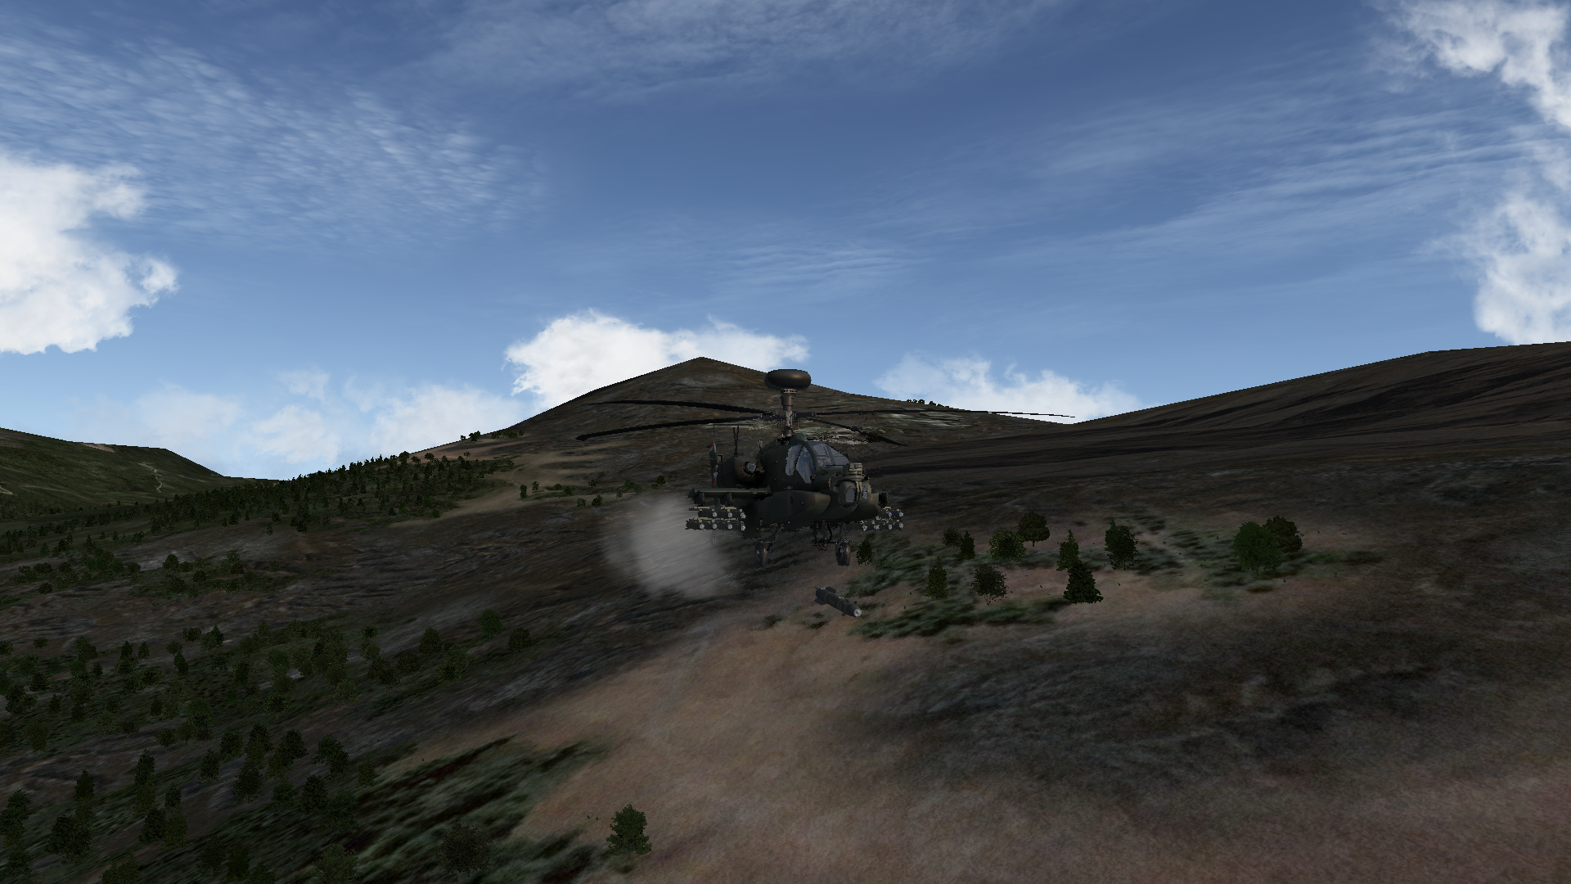

Falcon BMS Helipack 0.2.1

Theater Manual 0.2.1 REV 0

Table of Contents
1 Quickstarter Basics 1
1.1 What is this? 1
1.2 Is the Flight Model accurate? 1
1.3 How do I install? 1
1.4 How do I fly? 1
1.5 How do I add this to another theater? 2
1.6 Changelog 2
2 On the Theater 3
2.1 Philosophy 3
2.1.1 Purpose 3
2.1.2 Accuracy 3
2.1.3 Graphics 3
2.2 Technical Hurdles and Limitations 4
2.3 Feature Improvements to Stock KTO 4
2.4 Available Helicopters 5
3 Training Missions 7
3.1 Overview 7
3.2 Helipack Training 01 (Flight) 7
3.3 Helipack Training 02 (KOTAR) 13
3.4 Helipack Training 03 (NOE) 18
3.5 Helipack Training 04 (Naval) 21
3.6 Helipack Training 05 (Night Ops) 23
4 Tactical Engagements 26
4.1 Helipack 01 SCUD Hunt 26
4.2 Helipack 02 Light Blitz 27
4.3 Helipack 03 Defensive Nightmare 27
4.4 Helipack 04 Escape From North Korea 28
4.5 Helipack 05 Alligator Attack 28
4.6 Helipack PvP 01 Mirror Skirmish 28
5 Campaigns 29
6 Strategy, Tactics, and Limitations 29
6.1 Role 29
6.2 Systems 29
6.2.1 FCR 29
6.2.2 TGP 30
6.2.3 Data Link 30
6.2.4 Laser 30
6.2.5 Radio 30
6.3 Buddy System 31
7 Weapons 32
7.1 Guns 32
7.2 Rockets 32
7.3 AG Missiles 33
7.4 AA Missiles 34
8 References 34

Quickstarter Basics
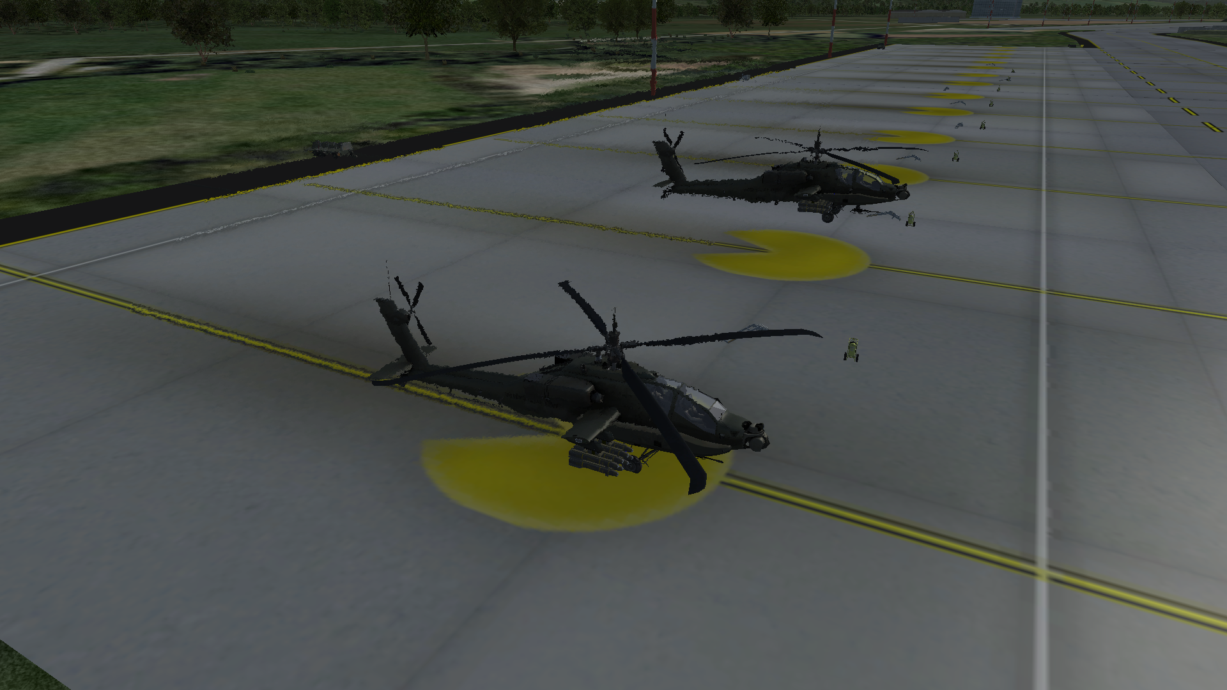Figure 1: Two parked AH-64s.

What is this?
Helipack is a 3rd party theater for Falcon BMS 4.35 based on the stock KTO theater. The main difference is that it allows human-flyable helicopters. This theater is based on the belief that flyable helicopters would drastically improve the already-excellent environment of Falcon BMS. See section 2.1 on our Philosophy for more information.

Is the Flight Model accurate?
There are many technical challenges that prevent us from achieving a perfect flight model. We make no attempt to say that our flight models are accurate; on the contrary, we know they are not even close to being accurate. See section 2.1 on our Philosophy for more information.

How do I install?
For the latest instructions, check the Github Readme.md file.

How do I fly?
The short answer is that you set your VTOL takeoff angle to 90° and give it some throttle. This will require you either to bind the VTOL callbacks or else to use the default keyboard bindings. See Section 3.2 for a walkthrough on the first training mission, which is meant to familiarize yourself with flying.
All aircraft in Falcon BMS are Vipers dressed up as other aircraft, although with differing flight models. The helicopters in this theater are no different. They use a modified Harrier flight model and Viper avionics. The F-16 ramp start procedure works for these helicopters. The main difference in flying these aircraft is that they are meant to be flown with VTOL set to 90°.
Lastly, be aware of your “never exceed speed.” For all variants of the AH-64, this speed limit is 197kts. Anything beyond this will bring the distinct possibility of damaging the helicopter.

How do I add this to another theater?
As development for this theater is still in its early stages, we hesitate to provide a list of changes at this point. Hopefully, this should change in a future release. We would definitely encourage people to include flyable helicopters in their theaters when the time comes!

Changelog
- Changed manual in a number of places.
- Updated Readme.md in a number of places. Added a warning that pilots should not overwrite KTO. (You two know who you are.)
- Fixed an issue with the ACD of the AH-1S pointing to the Longbow radar despite the AH-1S vehicle pointing to no radar.
- Fixed an issue with radar entry in VCD and ACD of AH-64E not matching.
- Added one song for music.
- Changed theater credits file(s).

On the Theater
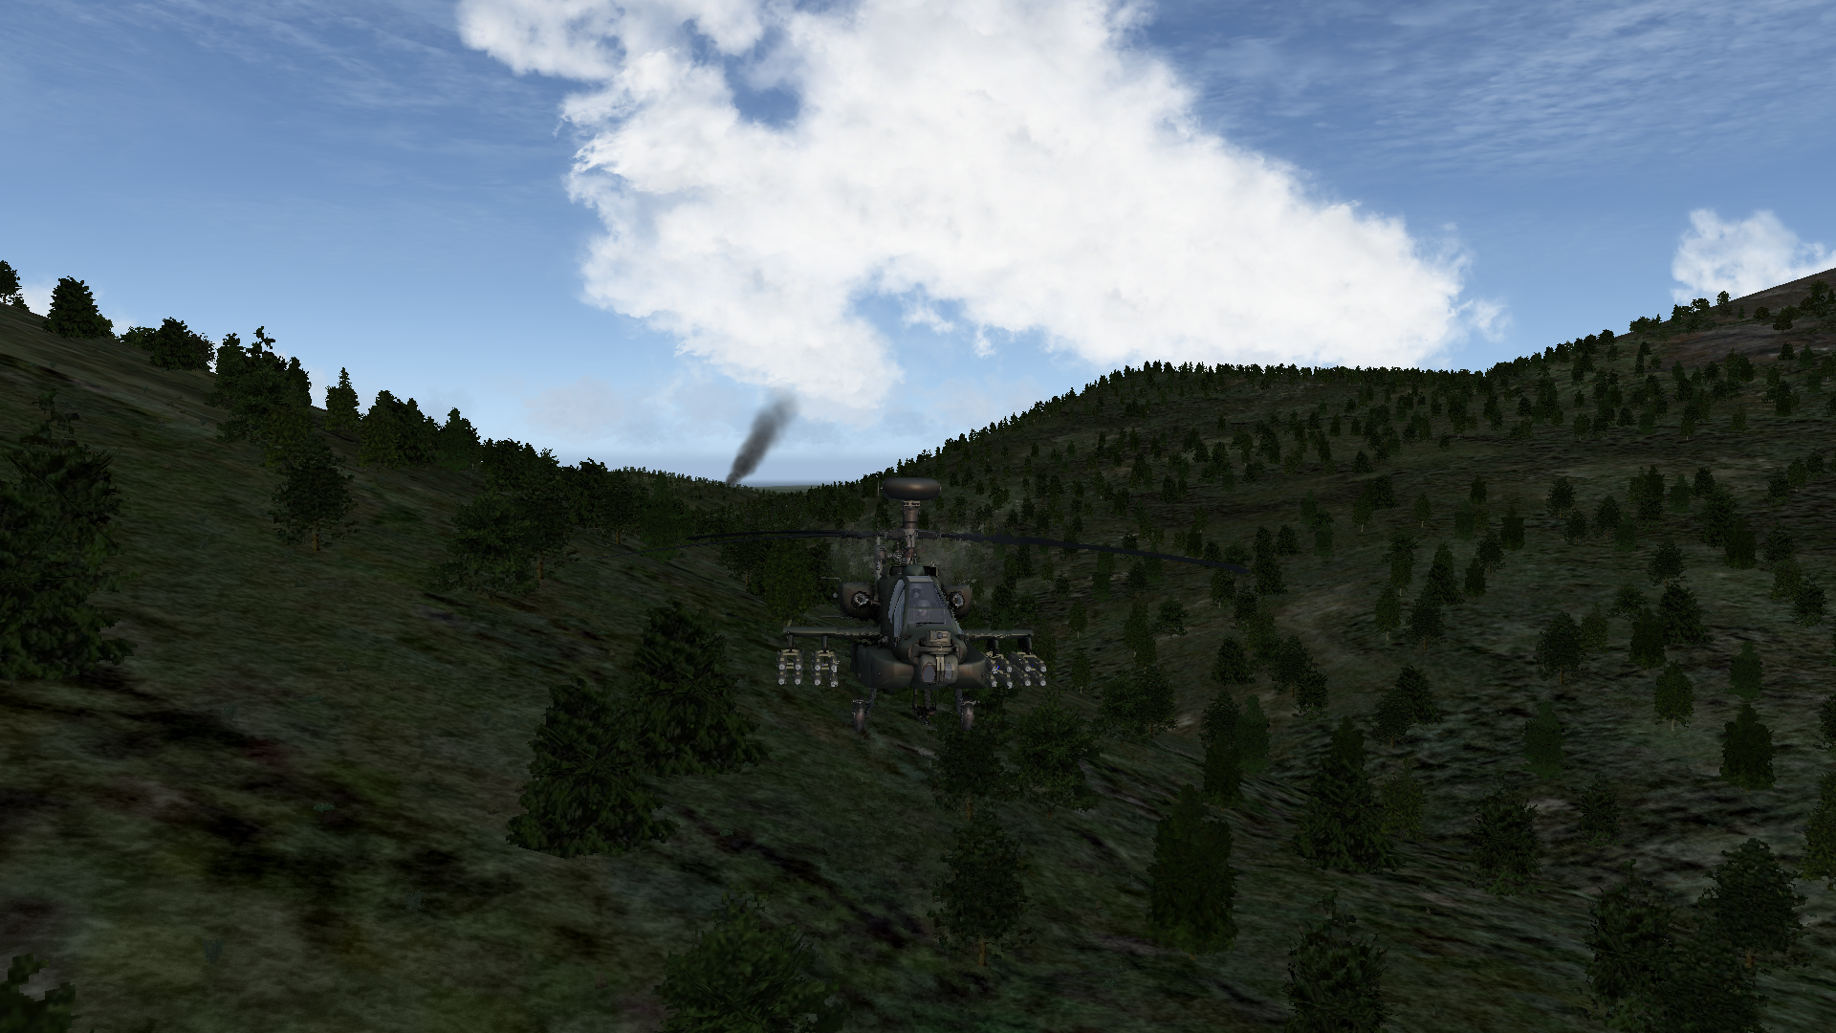Figure 2: An AH-64D can carry up to 16 AGM-114 missiles.

Philosophy

Purpose
- Human-flyable helicopters are an asset for Falcon BMS.
- We hope that human-flyable helicopters are picked up by the Falcon BMS developers and officially supported, eventually making this theater obsolete.

Accuracy
- The flight models are NOT accurate, nor do they have to be accurate to make our point that Falcon BMS would benefit from official dev support for flyable helicopters. With that said, if the reader wishes to contribute to the flight models, we are interested.
- The weapons and loadout may not be accurate. We are open to the idea of changing these, but we believe that these types of changes are best slated for official dev support.

Graphics
- Art assets such as new cockpits and additional models are nice but not 100% necessary at this point, as this project is supposed to be temporary. We value the flying experience over the graphics. With that said, if the reader wishes to contribute to the graphics, we are interested.
- We would prefer that any 3D cockpit for any of the helicopters provide controls for F-16 avionics. For example, an AH-64D cockpit should have an ICP with all of the F-16 ICP buttons, even if they are done in the art style of the AH-64D and in the position where one might expect to find something in the AH-64D resembling the ICP. We want people to be able to ramp start in the pit with buttons and switches that are accurately labeled. When BMS gets custom avionics, only then would full fidelity cockpits would make sense.

Technical Hurdles and Limitations
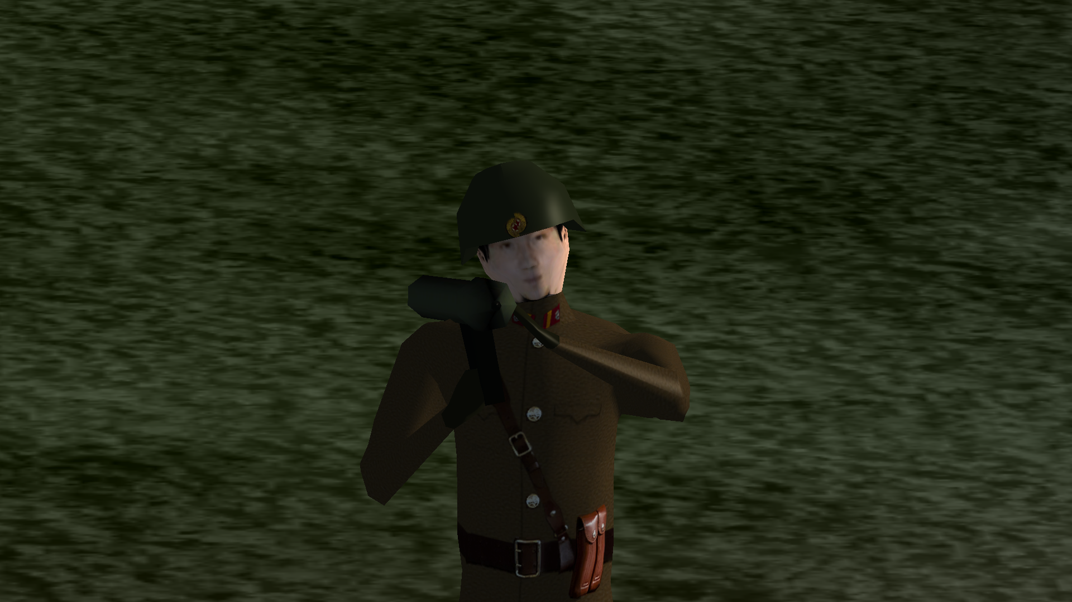Figure 3: Soldiers, including those holding SA-7 and SA-14 hand-held launchers, are visible in this theater. These soldiers are incredibly tiny.
For a complete list of current problems, please see the Trello in Section 6. The following incomplete list should provide some idea of the challenges to this project:
- The helicopters without radar will cause CTDs if you equip Maverick-based missiles. This affects both the AH-64A and the AH-1S.
- Rotor blades for the current helicopter models move only slightly in connection to player input. The rotor blades do not spin normally. Although they move slightly, they give off a perception as if they are completely stationary.
- Humans cannot spawn in helicopters on the ground at Army Bases.
- The AI cannot fly the helicopters once they are converted to be human-flyable. They crash pretty sadly.
- ATC is not prepared to handle helicopter arrival and departure.
- A human pilot cannot land the helicopter on a helipad.
- The landing gear must be retracted after takeoff, even if the real helicopter doesn’t support gear retraction.
- Humans aren’t allowed to use trainable guns; the gun is fixed.

Feature Improvements to Stock KTO
This theater introduces some fixes and improvements to Falcon BMS.
- Soldiers are visible in 3D.
- Rocket pods do not fire all of their rockets when the weapons release button is pressed. Pilots have the option of firing in single or pair.
- AH-64E has ammo for the gun.

Available Helicopters
Nationality | Helicopter | Has Radar | Fuel | Never Exceed Speed | Guns | Rockets | AG Missiles | AA Missiles
American | AH-64A | No | 2442lbs | 197kts | 30mm M230 | LAU-3/A /HE (G)  LAU-3/A MPSM (G) | AGM-114 Hellfire | N/A
American | AH-64D | Yes |  |  |  |  |  | AIM-92 Stinger
American | AH-64E | Yes
American | AH-1S | No | 2086lbs | 190kts | 20mm M39-2 | LAU-3/A /HE (G)  LAU-3/A /MPSM (G)  LAU-68/131 /HE  LAU-68/131 /WP  LAU-68/131 /MPSM | BGM-71 TOW | N/A
Russian | KA-52 | Yes | 2500lbs  Tank 550li | 189kts | GSh-23-6 | B8V20-A | AT-9  AS-10MR (Kh-25)  AS-20 (Kh-35) | AA-11 (R-73)  AA-8 (R-60)
Russian | KA-52K | Yes
Right now all of the helicopters share the same flight model with the following exceptions:
- “Never exceed” speed
- Internal fuel
- Weapons loadout
Eventually we will hopefully see further differences including:
- Gear details
- Collision details
- Center of Gravity
The AH-64D has received the most focus. The AH-64A and AH-1S are not supported yet, since their lack of any radar system causes CTDs when you bring their most effective Air-to-Ground weapons. To get the most out of the flying experience, focus on flying the AH-64D.

Training Missions
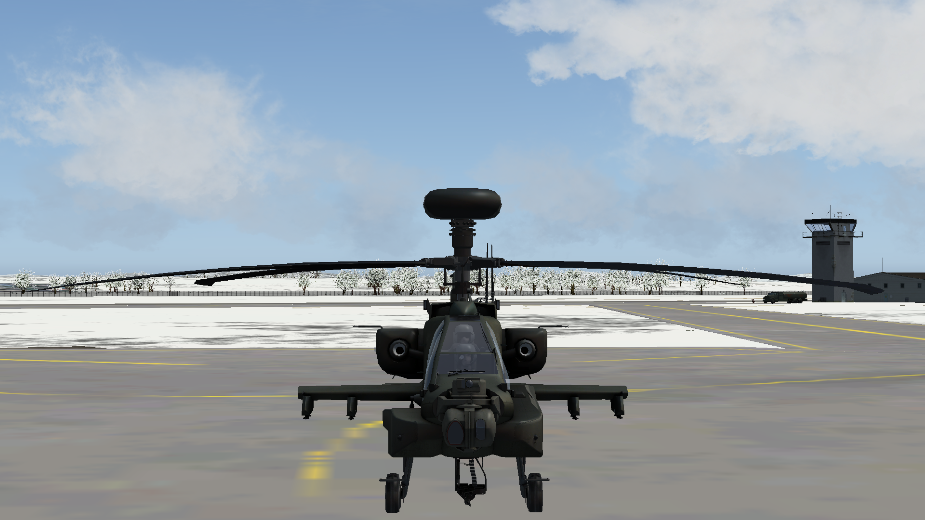Figure 4: You can already fly the F-16 and now you want to fly this bad boy? Good. You're reading the right document.

Overview
The training missions are designed to familiarize a seasoned Falcon BMS pilot with flying helicopters. This manual assumes that the reader is proficient in Falcon BMS, and does not explain basics with regard to the F-16. It is advised to consult the Falcon BMS manuals first if anything is unclear.

Helipack Training 01 (Flight)
Goal: To take off, navigate, and land safely.
Prior to Loading into Falcon BMS: It is optional, but you should consider binding the VTOL Increase Angle and VTOL Decrease Angle buttons. The default keyboard commands for these callbacks are Shift + Period and Shift + Comma respectively.
When in 2D: Slot into Rescue 1-1. Perform the “click dance,” ensuring you have your comms ladder properly saved into your DTC. There’s not much else to do here. You’re good to commit. Select Ramp or Taxi start.
When in 3D: If you selected Ramp Start, begin by performing your ramp start as you would if you were in the F-16. This should be entirely familiar to you.
When your jet is ready to Taxi, you have the option of following ATC or not. Let’s try our best to follow the rules for now. Go ahead and ask Ground for taxi clearance. When you’re cleared to taxi, begin taxiing very slowly to the runway. The brakes are very loose and do not work properly as of yet. Be very careful. Continue the normal process of getting clearance from Ground. Switch to Tower when cleared.
After you’ve been passed on to Tower, request takeoff. Taxi onto the runway when prompted, being very careful not to slide off the runway. When you’re parked on the runway, go ahead and move the VTOL position to 90°. You should see confirmation you’re doing it correctly if the display in the upper right hand corner increases in angle from 0 to 90 by increments of 10 for every button press. Turn your Alt. Radar to Baro now.
Takeoff: When you’re ready to take off, increase the throttle gently and aim for an altitude of 500ft AGL. The throttle acts as the helicopter’s collective – at least in some sense. More throttle means more lift. Less throttle means less lift. If you leave the throttle too low for too long, the helicopter will suddenly plummet. Unfortunately, once you begin free-falling, you must overcome your descent quickly. These helicopters can drop like rocks if you’re not focused.
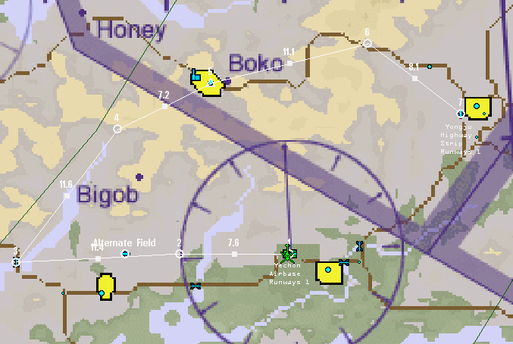Figure 5: The flight plan. It's not so bad, is it?
Pay careful attention to your FPM. The FPM is going to be your information lifeline to tell you where you are headed in 3D space. If the FPM is above the Artificial Horizon line, you’re set to climb. If the FPM is below the line, you’re falling. If you can’t see the FPM, this could be a very bad sign that it has dropped far underneath you (or you’re not looking straight in relation to your motion). Never let the FPM dip too low.
Once you’re at 500ft, retract the landing gear. Although the gear doesn’t actually move on the AH-64 3D model, it’s still necessary to raise the gear for the sake of the avionics. Betty may begin complaining that you’re not in a proper Takeoff/Landing config once the gear comes up. Ignore her. If she bothers you too much, you can mute her with the Voice Inhibit switch on the right-hand of your seat.
Tell Departure that you are airborne, and then switch to Tactical. You’re now ready to fly, but let’s get some practice in first. We’ll try to work on controlling your altitude for now.
Hovering: Try to hold the helicopter at 500ft for a bit. When you’re satisfied you can hold it, drop to 400 ft slowly. Maintain that altitude for 10 seconds. When you’ve managed that, try to increase your altitude to 500ft again. Get used to moving the throttle around and recovering lost altitude. It can be a bit difficult to maintain control while under fire. Now is a perfect time to get used to it. Switch to an arbitrary altitude, and try to hold the helicopter in a hover. See how the helicopter performs at different altitudes just hovering.
Basic movement: When you’re ready to begin your journey, select STPT 2. Use your rudder to rotate the helicopter until you face STPT 2. You’ll be using a lot of rudder when flying at a hover, so it’s a good idea to have rudder controls accessible. Pitch the helicopter down slightly. If the altitude drops, you can raise the throttle. Maintain a balance so that you don’t trade too much altitude for forward momentum. Eventually you should begin moving forward.
Feel free to experiment. Stabilize the helicopter back into a hover, and experiment with rolling slightly over to the side. Use the rudder to swing the helicopter around to face the direction you are traveling in. Try to bring the helicopter back into a hover by countering the motions. Don’t forget to maintain your altitude as you are doing this.
When you’re attempting to hover or move from a hover, you should keep an eye on your alpha. Alpha may be more useful in an F-16, but we need to use the tools at our disposal. When you get used to relating alpha to your movement, it should provide you with some context clues about what is happening in 3D space. Your alpha, although based on relative pitch, may provide you with some context clues as to whether you are stationary, traveling forward, or traveling backwards. If you are hovering and suddenly find yourself moving backwards, you’ll notice that your alpha will begin to show different values than if you were drifting forward. Expect the helicopter to fly differently when traveling backwards.
Navigating: When you’re ready to proceed, focus again on STPT 2. Begin moving forward at a comfortable rate to STPT 2. As you fly, continue to keep an eye on your FPM. This will now indicate where you’re traveling, and whether or not you can clear a hill in front of you. If the FPM is struggling to get above the mountain, even with increasing the throttle, this won’t work without additional input. Pitch up to compensate and gain more altitude. You’ll slow down a bit, but at least you won’t become a pancake.
Your Never Exceed speed is 197kts. Do NOT exceed this speed, or you may damage the helicopter. Black smoke will begin pouring out from the back of the helicopter, and flames will shoot out of the back of your seat. It’s easy to miss this damage if you’re not paying attention, so keep an eye on your HUD.
Follow the flight plan, and try to stay under 300 AGL. Just beyond STPT 2 is your alternate airfield at STPT 8. If something went wrong, you can try landing there. Otherwise, continue onward to STPT 3. You’ll see STPT 3 is located at a bridge. Fly past the bridge and turn right toward STPT 4. You’ll need to use a combination of roll and rudder to make the turn if you’re traveling near the high end of your maximum speed. It’s easy to “wipe out “by applying too much of the wrong input. Turn slowly and get a feel for what the helicopter is doing. If it feels like it’s going to roll over too hard, compensate by easing your turn. You might need to increase the throttle as well.
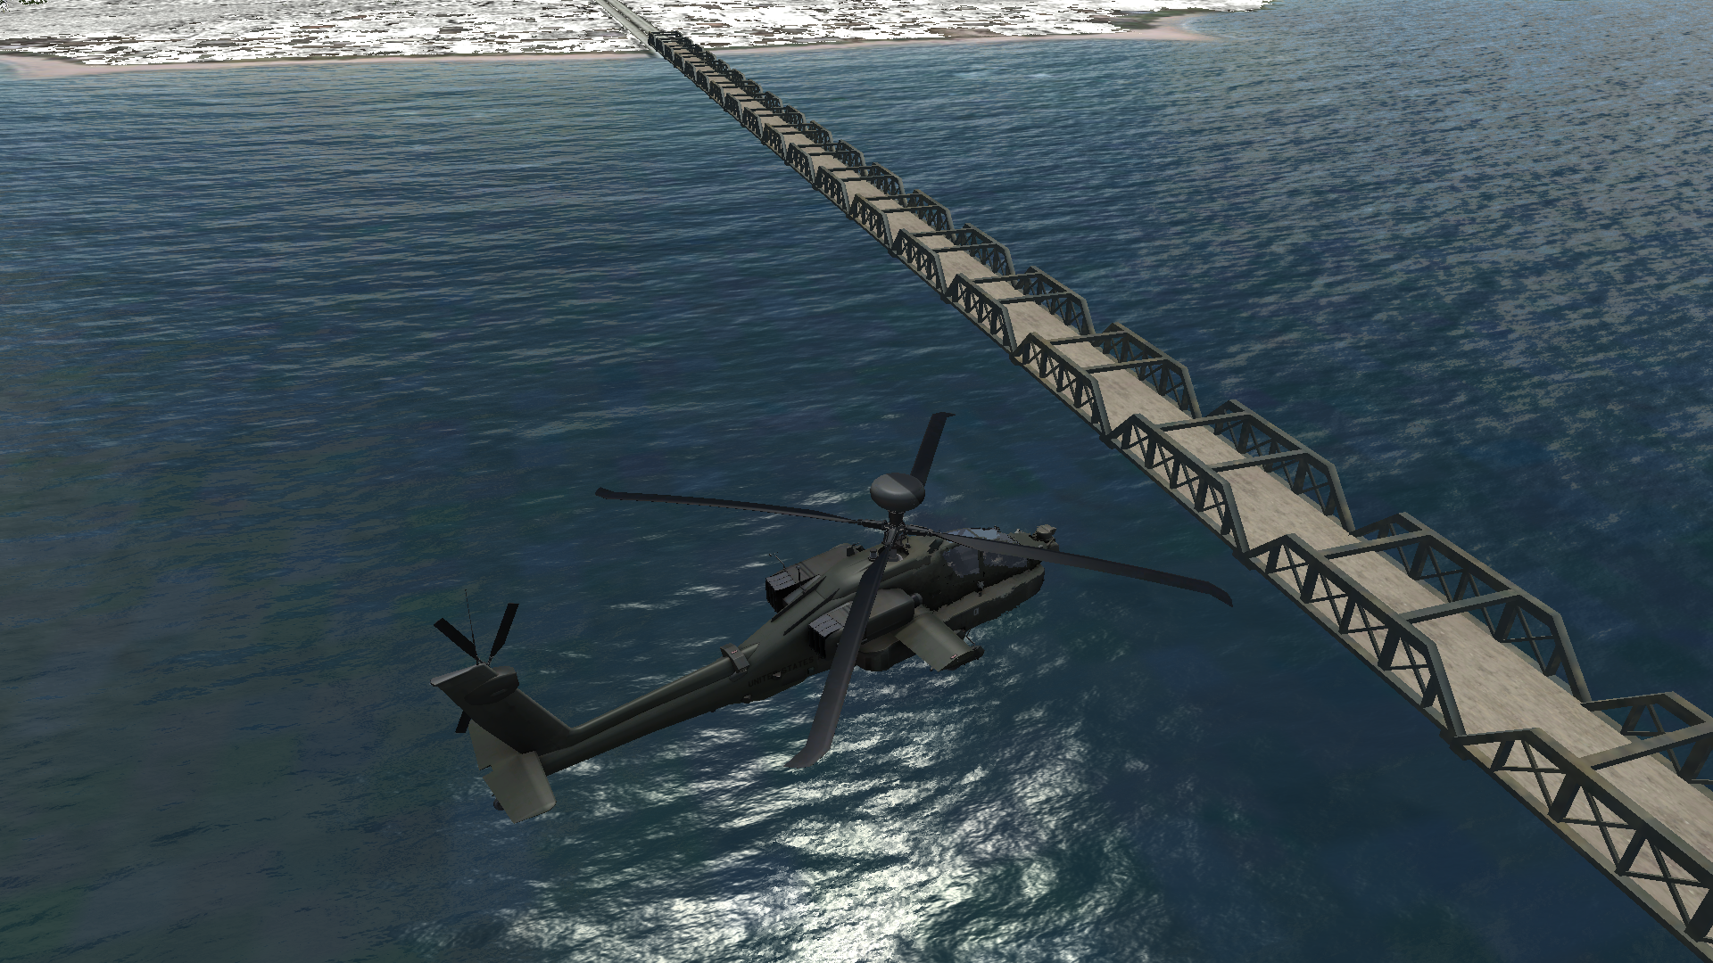Figure 6: Crossing STPT 3 which is located at this bridge.
Continue to follow the flight plan, and enjoy the scenery. At STPT 4, you’ll have some mountains to cross. Maintain focus on your FPM as you approach the mountains. Look around you, and see how the hills and mountains look from your position. Look up above and see if you can spot the contrails of the AWACS above you. He is most likely somewhere to your left. This is actually easier to spot aircraft from the deck than you might imagine. Take advantage of it when you can.
STPT 5 is located just over these hills at a city. Fly through the city at very low altitude, but be careful not to hit any buildings. This should give you a sense of speed and perspective.
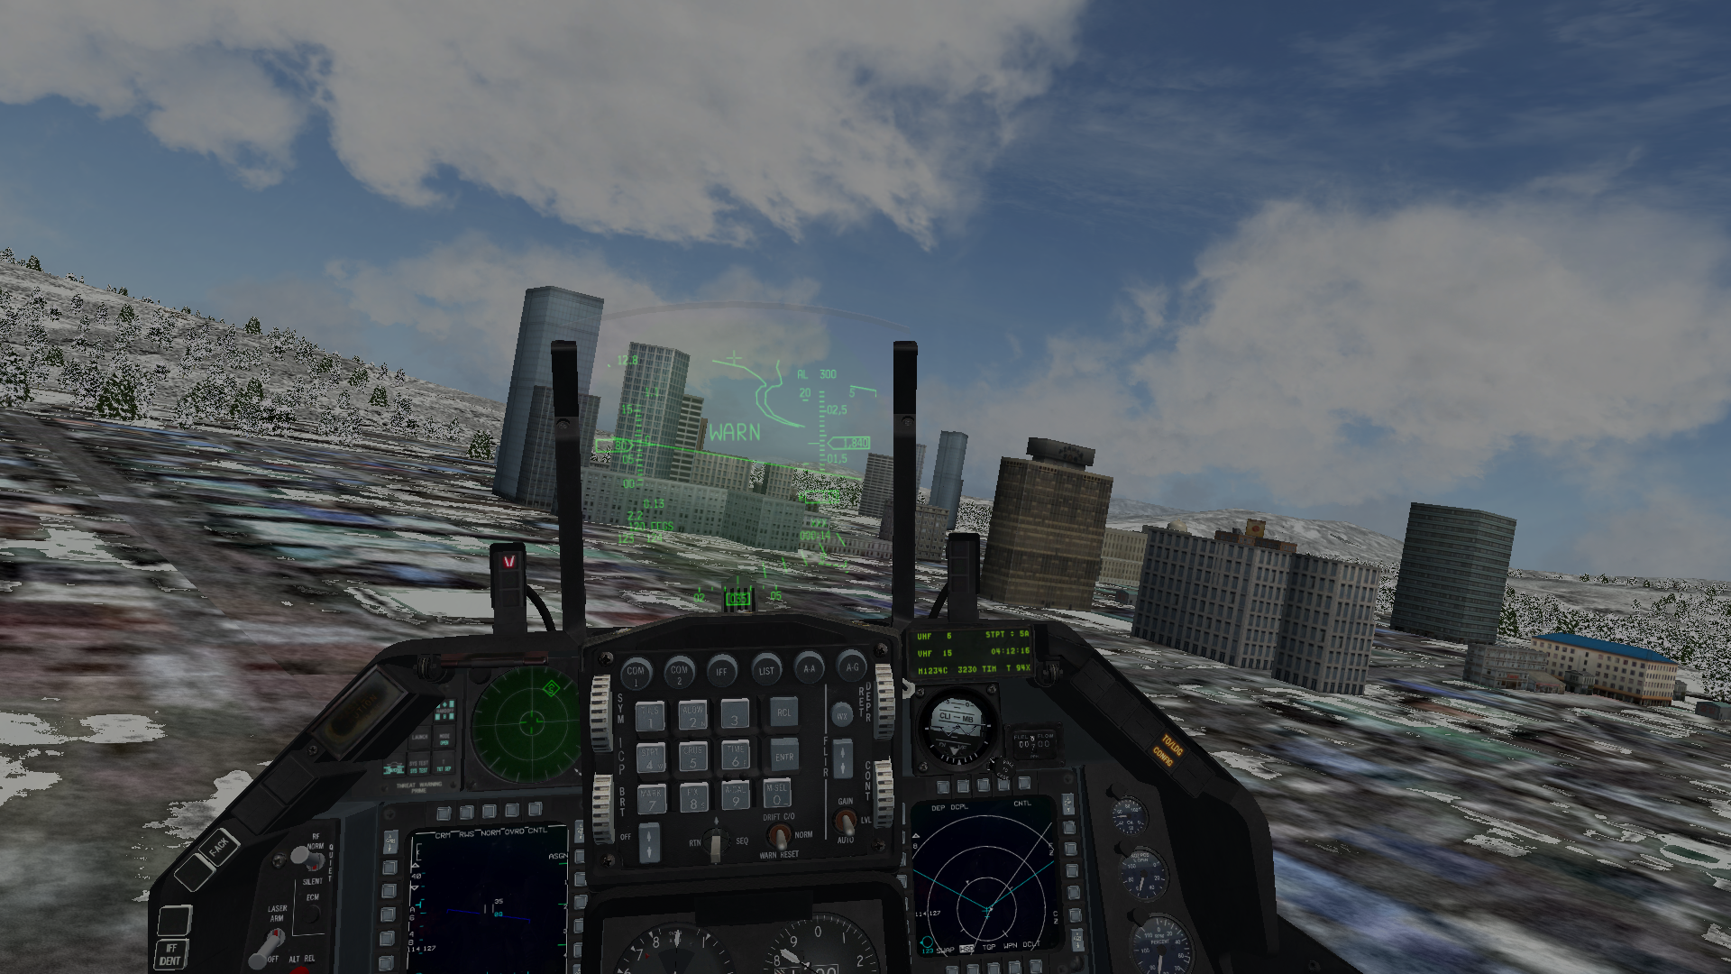Figure 7: Flying through the city at low altitude. Buildings can be intimidating. Watch yourself.
Approach and Landing: When you are getting close to your destination, switch to the Approach frequency. Remember, your landing destination is at a different airbase. Go up the comms ladder to UHF 7 (as opposed to going back down to UHF 4). Request an unrestricted landing. Continue the procedure as if you were in an F-16 coming in for a basic, straight-in approach.
Approach should pass you to Tower. Because we want to follow the ATC rules today, you’ll be landing on the runway. This should be easy if you can maintain control of the helicopter at all times.
The suggestion for today is to try a very slow landing. When you’ve got the hang of flying, you can come in faster. When you are on final approach, aim for 100ft, and decrease your speed to 60kts. You can do this by lowering your throttle and pitching up slightly. You’ll need to balance the pitch and throttle to achieve the desired altitude and speed. If the speed on your HUD reads 0 kts, then you’re actually slower than 60kts. You can see your ground speed by switching to the INS page on the DED.
It’s important to note that if you slow down too much, you’ll begin flying backwards. As mentioned previously, the helicopter will handle differently. While it’s possible to fly backwards, you may initially find it very difficult to maintain stability in this state.
Now that you’re slow and ready to land, lower your landing gear. Ensure you have three green lights as you would in a normal landing in the F-16. You’ll want to be in a near-hover over the threshold of the runway with some small, forward momentum when you cross it. Your speed and the FPM should be your focus at this point. The latter will give you an idea of where you’re aiming to touch down.
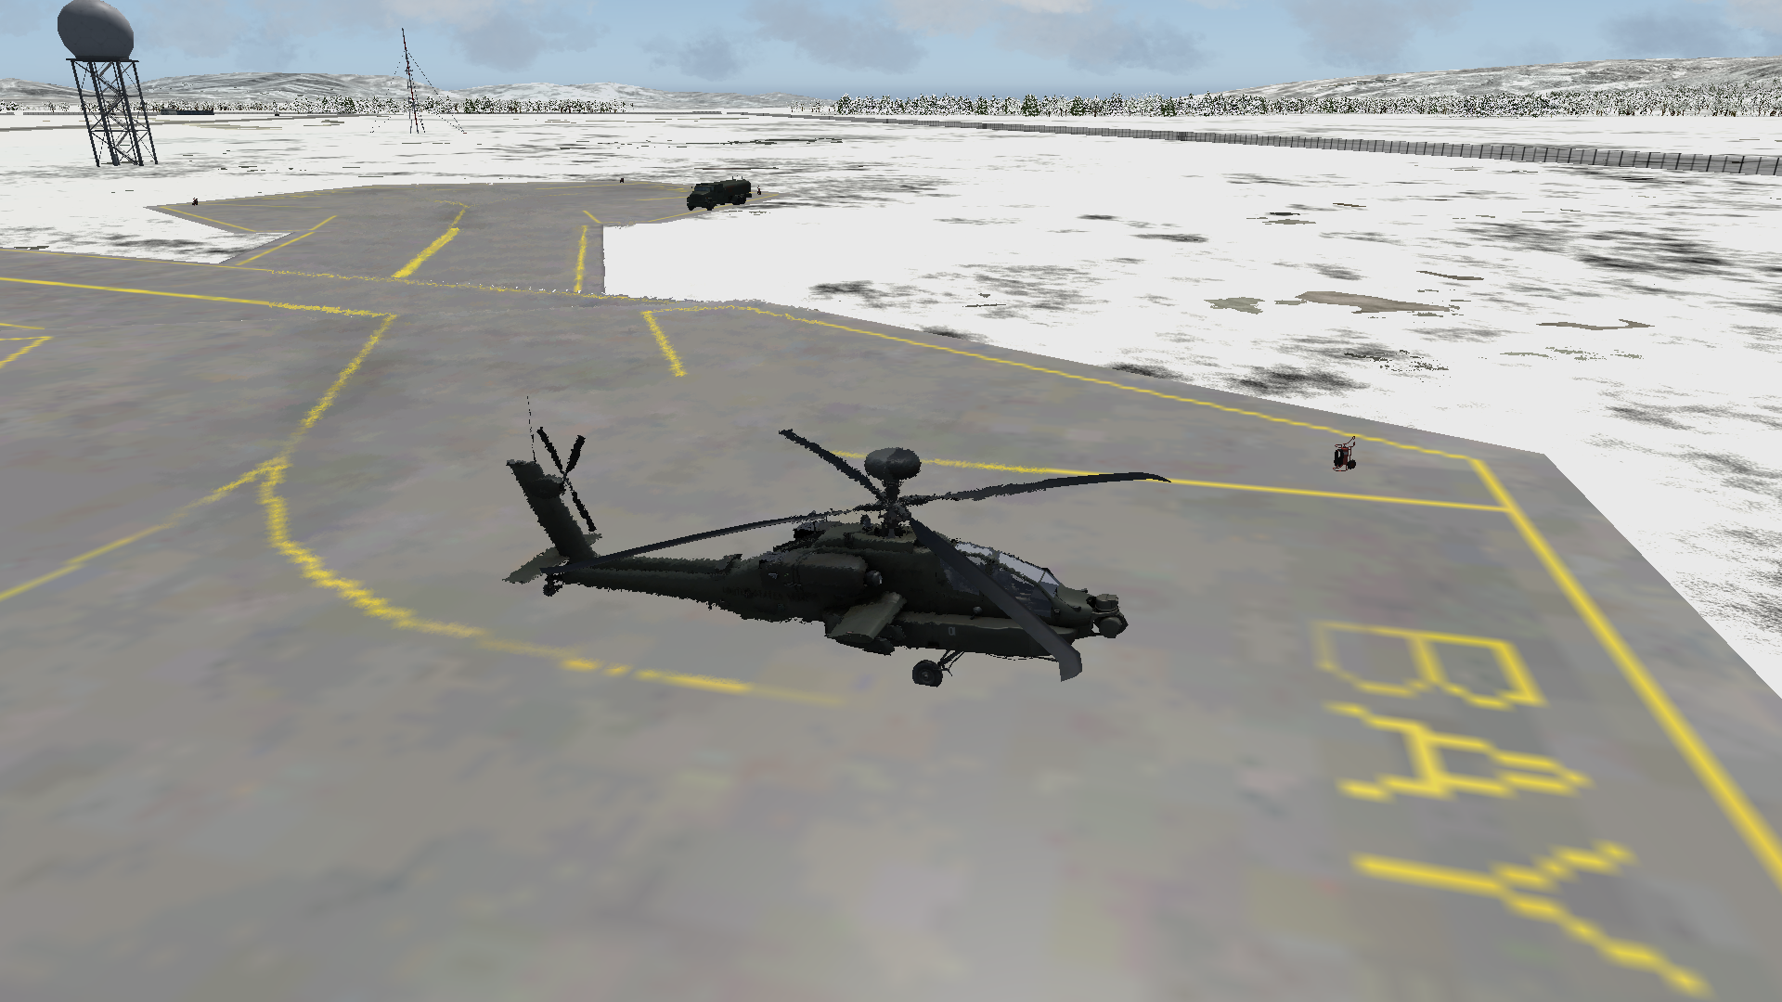Figure 8: We’re parked after landing. Whew. Stressful, right?
Now put the helicopter down slowly and gently. You may bounce. ATC may even consider this a non-landing and revoke your clearance. This is OK. Just put it down as gently as possible, and drop the throttle upon initial contact with the ground. Hold the wheel brakes until you come to a complete stop. Set the VTOL exhaust angle to 0°.
Request Taxi back to hanger, and once cleared, taxi slowly and safely off of the runway. Park it at one of the parking places marked BAY 1, and shut the helicopter down. The procedure for shutting down is the same as if you were in an F-16.
If you managed to land without damaging the helicopter, congratulations. You deserve it.

Helipack Training 02 (KOTAR)
Goal: To become acquainted with the three types of weapons that the AH-64D offers.
Prior to Loading into Falcon BMS: It is optional, but you should consider binding the VTOL Increase Angle and VTOL Decrease Angle buttons. The default keyboard commands for these callbacks are Shift + Period and Shift + Comma respectively.
When in 2D: Slot into Gazelle 5. We’ll be flying to the training range known as KOTAR. Open your DTC and ensure that the following targets are already set:
- STPT 99: Bonghwa Building 36^ 56.881’ / 130^ 11.796’
- STPT 98: KOTAR RNG M2A3 Dummy – 37^ 07.715’ / 130^ 20.670’
- STPT 97: KOTAR RNG Vertical Tgt 1 – 37^ 07.839’ / 130^ 20.674’
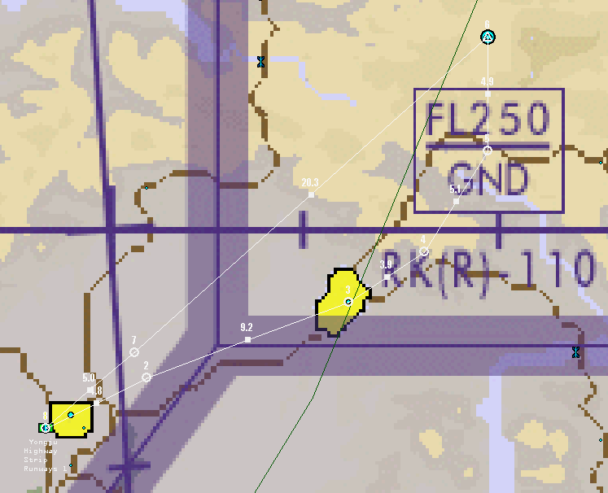Figure 9: This is the flight plan for the training attack at KOTAR. Boresight at STPT 3 and attack at STPT 6.
- STPT 96: KOTAR RNG Vertical Tgt 2 – 37^ 08.026 / 130^ 20.653’
If this is not correct, then assign the STPTs manually as follows:
- Recon STPT 3 and assign STPT 99 to the fourth target from the top: “Building.”
- Recon STPT 6 and assign the following:
  - STPT 98 to the first “RNG M2A3 Dummy” in the list.
  - STPT 97 to the first “RNG Vertical Tgt 1” in the list.
  - STPT 96 to the last “RNG Vertical Tgt 2” in the list.
Perform the “click dance,” ensuring you have your comms ladder properly saved into your DTC. You’re ready to commit. Select Ramp or Taxi start.
When in 3D: If you selected Ramp Start, begin by performing your ramp start as you would if you were in the F-16.
Before you are ready to takeoff, power on your AGM-114 missiles. They take 3 minutes to power up normally, because they are implemented in Falcon BMS as if they are AGM-65 Mavericks. It will be assumed that you are familiar with AGM-65 usage, and will remember to use the Uncage button to blow the cover off of each missile as required. You’re close enough to the range that you can probably afford to leave them on, but in a normal mission, consider turning them off as soon as the SMS page indicates they are RDY, in order to save the battery life.
When you are airborne, fly to STPT 2, and continue toward STPT 3. STPT 3 is where you will begin boresighting. When you’re within 5nm of STPT 3, select STPT 99. Switch Master Arm to SIM, and boresight your AGM-114s on the building in question. You’ll need to perform this four times, once for each pylon.
You may notice that when you switch pylons and cycle back, your AGM-114 loses its lock. Lock are NOT maintained as you cycle pylons. This means that when you attempt to ripple multiple AGM-114 missiles, you will still need to reacquire your target prior to firing each missile. Ripple firing is essentially not allowed at present, although a fast pilot can still fire off four missiles fairly quickly. Set Master Arm to OFF when you’ve completed the boresighting process, and consider powering off the AGM-114 missiles.
Perform your FENCE IN routine by the time you get to STPT 4. Power on your AGM-114 missiles. Wait at STPT 4 until the missiles are ready. When you and your weapons are ready, head toward STPT 5. Position yourself in a hover when you’re at STPT 5. You’re ready to prosecute your targets.
AGM-114 PRE shot: Select STPT to 98. This is the first target. Ensure that your AGM-114 mode is set to PRE. This will give allow you to obtain a view with the TGP on the target in question, just like when you were boresighting. Lock up the target with the TGP with Point Track. The other MFD should have your WPN page. When you have a lock, DMS Down to switch SOI from your TGP on the one MFD to your WPN page on the other MFD.
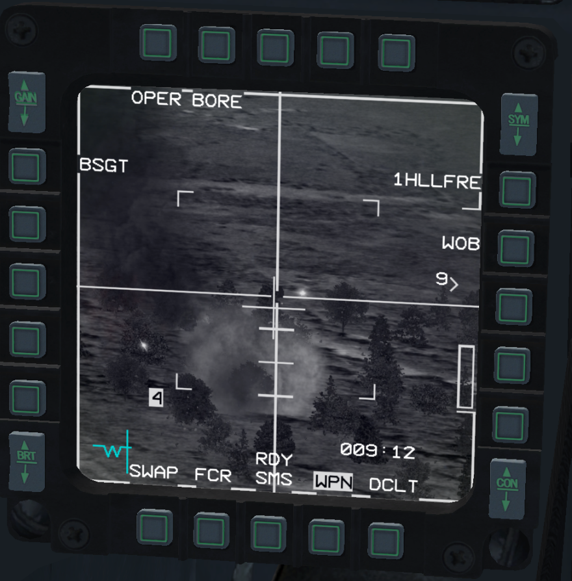Figure 10: This pilot has 1 AGM-114 left. He's been busy. This is in BORE mode and not PRE or VIS. BORE is similar to VIS in some respects.
Attempt to lock up the same target on the WPN page with TMS Up. Since the AGM-114 camera is weaker than the TGP, it is possible that it may lock onto the wrong target. You may have to adjust your position, or slew the camera to a slightly different location before the missile and TGP are locked onto the same target. When you’re firing at hostile tanks that are close together in a real combat situation, this lack of precision of the AGM-114 seeker may not matter as much, and you might be content to fire on any tank that is within the TGP view. This will depend on your mission.
Ensure you are in range. Ensure that you are locked onto your target. If the AGM-114 has a lock, it will allow you to boresight the missile. If you don’t have a lock, the option to boresight will be missing from the WPN page. Ensure the cross on the WPN page is NOT blinking. When you are ready, and all requirements are satisfied for a good shot, press the Weapons Release button. A missile should fly off the rack, and your WPN screen should go black. If you’re fortunate enough to be in a good position, you should be able to visually follow your missile as it flies forward from your helicopter, lofts into the air, and comes down onto the target. The missile is slow compared to other weapons, so give it some time. You should see a splash somewhere within a minute – hopefully you will have a capture on the TGP of a successful first shot. If so, congratulations!
If you missed, try again. If you miss again, perhaps you’re missing an easy step, such as firing when the cross is flashing, or you didn’t really confirm that you were in range. It’s also possible you thought you had a lock with the AGM-114 but did not. Make sure that the WPN page is holding a lock before you fire.
AGM-114 VIS shot: After a successful PRE shot, try a VIS shot. VIS is, as the name implies, for when you see a target visually and want to fire at it. Make the WPN page’s MFD the SOI, and Press Cursor Enable. Alternatively, use the MFD button marked PRE to switch to VIS. You should see a box on the HUD now. Use the cursor slew to move the box, and then TMS Up when you’re close to one of the other dummy vehicles.
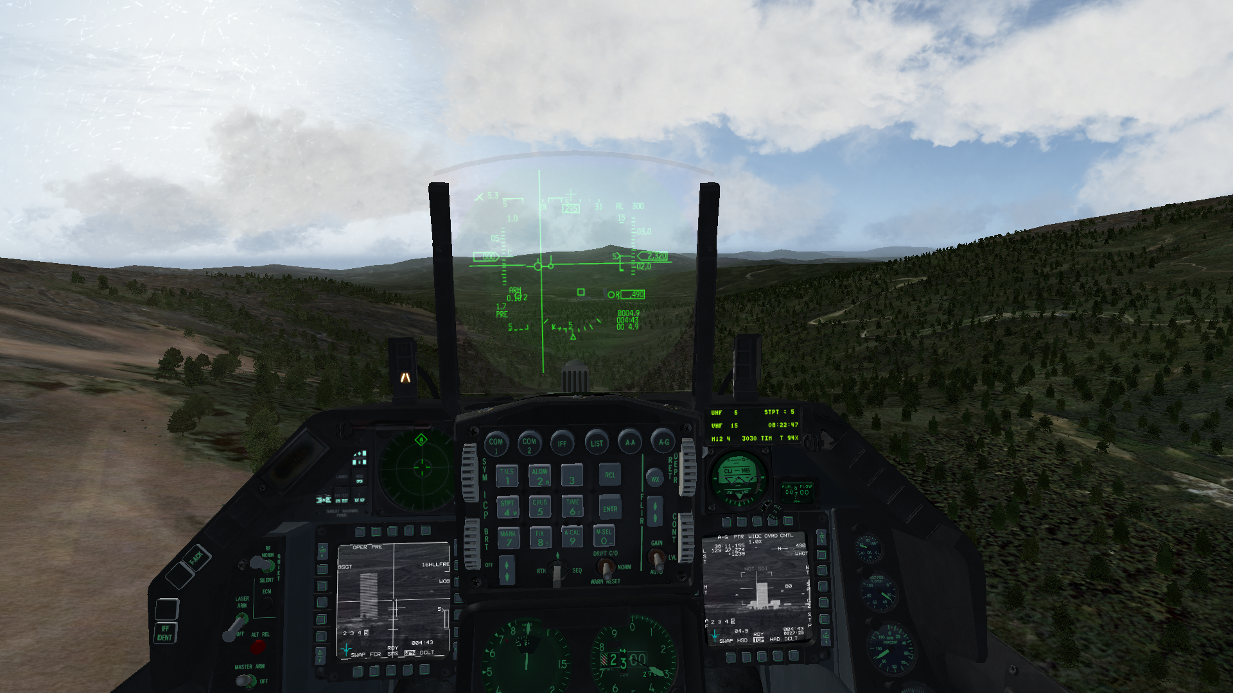Figure 11: This picture shows a pilot running a different mission with the WPN page on the left MFD and TGP on the right MFD. This is just one strategy.
Now slew the AGM-114 onto the same target. You’ll notice that a circle has appeared on the HUD on the box. You are now controlling this circle with cursor slew. You may also notice that the circle and the AGM-114 are not perfectly aligned. Something is wrong with the way the system handles this offset, but no worries – you can compensate. First use the HUD as a basic guide to get you “close enough” to the target as you move the circle to the target in question, and then obtain the final lock by using the WPN page as your final visual cue.
You won’t get range information from VIS mode, so you’ll have to know your range to your target. Go ahead and fire off that AGM-114 when you are confident that you are within parameters, and then sit back and enjoy the splash.
When you’re confident that you can launch in VIS mode, use the rest of your AGM-114s however you’d like. When you’re done with the AGM-114 missiles, power them off.
LAU-3/A /HE (G): Switch to rockets. You’ll notice that the WPN page says M151H19. The M151 is the rocket pod ammunition type, and the H stands for HE (ie. High Explosive). The 19 stands for how many shots you have in one rocket pod. This number won’t decrease, sadly, as you fire. You’ll have to maintain a mental count of how many pods and how many rockets that you have onboard.
Select PAIR in the WPN page. Select STPT 97, and fly forward as if you were going to overfly the target at very low altitude. Aim for 200ft AGL. As you get close, you’ll want to place the pipper on the target and fire. Light up that target with 5 presses of the Weapons Release button in rapid succession when you’re close. Overfly the target.
At your earliest chance, turn around safely, and perform an assessment. Did you hit the target? If the rockets missed, where did they go? You’ll probably notice that the pipper isn’t quite accurate for precision attacks. That’s OK; you have 19 rockets per pod and 2 pods for a reason. Try another pass if you missed. If you succeeded, try another target of opportunity.
Use the rest of your rockets however you’d like.
Guns: When you’re done with the rockets, it’s time for guns. Press Uncage Long while in AG Master Mode. You’ll switch to your gun. Choose STPT 96. Perform a flyover just as you did with the rockets, but this time use the Second Trigger Detent with quick bursts of gunfire, correcting as needed. You’ll probably notice that the gun position isn’t quite correct, either, but you should be able to compensate and destroy a target. Press Uncage Long to deselect your gun when you’re done.
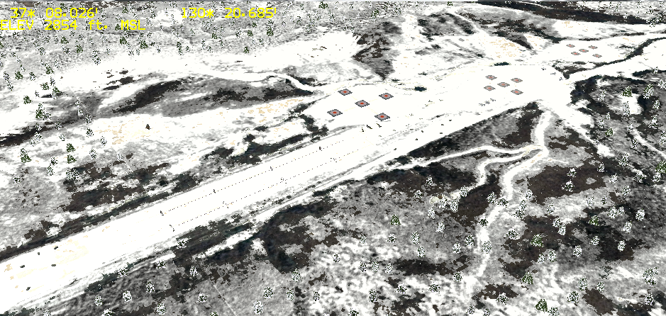Figure 12: KOTAR in winter.
In a real combat scenario, the TGP is slaved to the gun’s eyes. Unfortunately, right now you cannot slew the gun, so this visual information is only useful if you’re going to try to identify or shoot at something from quite the distance. This might work if you’re attacking a large building from far away.
Fly back to base when you’re done. Congratulations on your first use of the AH-64D weapons.

Helipack Training 03 (NOE)
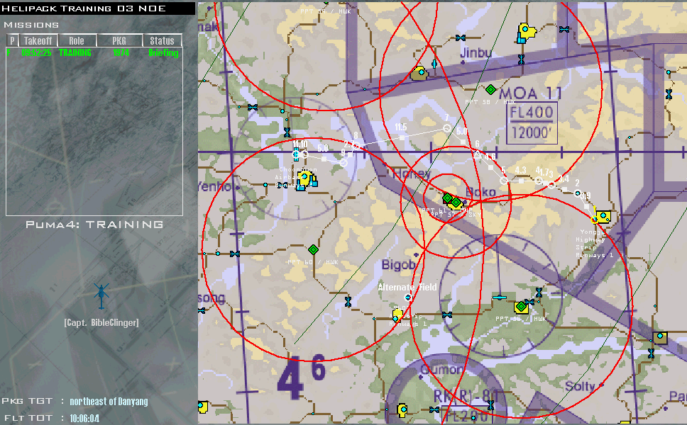Figure 13: Our flight plan. This might look daunting, but the HAWKs will struggle to see you -- IF you fly NOE.
Goal: To become proficient at maintaining low-level flight.
Mission Background: Scramble and fly through a No-Fly zone. This zone will be defended by Hawk batteries. You are NOT authorized to shoot at them. You must navigate the gauntlet at low level. Also, you’re on a time table. You have 30 minutes from entering 3D to make it to your destination.
Prior to Loading into Falcon BMS: It is optional, but you should consider binding the VTOL Increase Angle and VTOL Decrease Angle buttons. The default keyboard commands for these callbacks are Shift + Period and Shift + Comma respectively.
When in 2D: Slot into Puma 4. Pay careful attention to your flight plan. Make sure the enemy air defenses are marked, as we’ll be using live air defense munitions this time. The threats are as follows:
- 1x Patriot
- 1xInfantry
- 1xSkyguard
- 4xHAWK
If you are missing the threats, see the associated picture. It is imperative that you know where the threats are.
Perform the “click dance,” ensuring you have your comms ladder properly saved into your DTC. You’re ready to commit. For this mission, it is recommended to select Taxi start.
When in 3D: We’re going to skip the ATC this time. You’re on a timer, so let’s get moving quickly. Set the ALOW and MSL Floor to sensible values, such as 50ft and 30ft respectively. You want to be less than 200ft AGL during this excursion, at least. In reality, you want to be less than 100ft – maybe even 50ft at times.
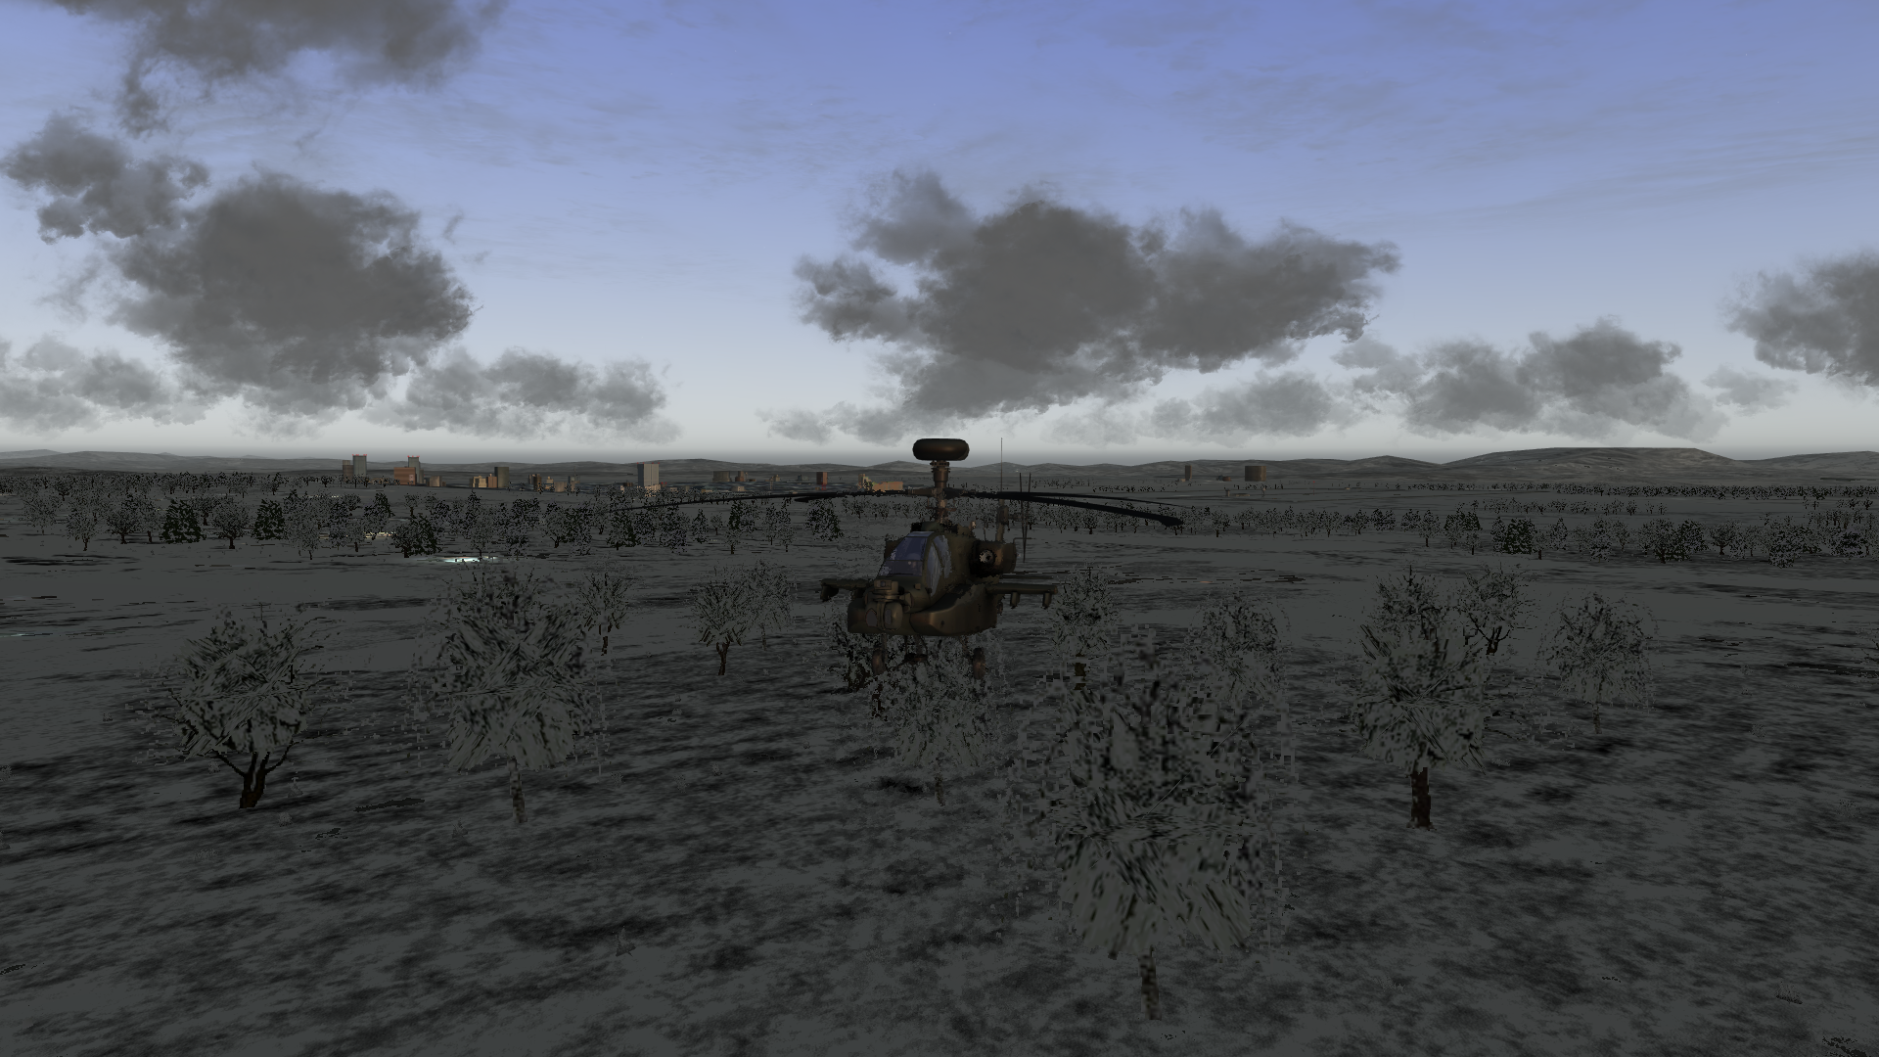Figure 14: We're skimming trees. Thankfully, for now, trees do not have hitboxes currently. This is supposed to change in a future version of Falcon BMS.
Set your RWR to scan for Low threats. Adjust your active countermeasures program. Select STPT 2. Set your STPTs to Automatic, so you won’t have to switch them manually as you fly.
Are you ready?
Last Minute Warning: Letting your altitude climb or drop too much is going to be deadly. The key is to maintain control of your helicopter at all times. The FPM should be in front of you. Keep it visually apparent on the HUD as best as you can. Make sure you know when to use rudder vs roll and vice versa. Don’t let the helicopter slide away from you.
Takeoff: Raise yourself off the ground, pull the gear, slam the rudder, and face the correct STPT. It’s time to hustle. Pitch down and increase the throttle. Find the balance between throttle and pitch. Don’t use the throttle alone to push yourself forward; forward momentum comes from a combination of throttle and pitch. The goal here is to do everything fast while still being 100% in control of the helicopter.
You should be getting an update in the upper right hand corner of your screen as to how much time you have. Don’t let the clock pressure you into doing something stupid. Try to maintain 140kts throughout the flight.
STPT 3 is where you are crossing into the first threat ring. The HAWK that is positioned roughly to your 3 o’clock should be harmless as there is a big mountain between you and him. Keep going, and don’t forget to climb the hills.
As you go through the mountain range, you’ll notice that there are some dips. Take these like a champ. Climb as the hill climbs and dip over the edge without going too low.
At STPT 6 and STPT 7, you’ll be in the most danger from HAWKs. If you receive a hard lock during your run, use your countermeasures, and keep going. The HAWK tracking radar displays as an ‘H’ symbol on your RWR. You should receive a launch warning if he actually gets a missile off. Use whatever cover you can get from the terrain to mask the line-of-sight that the SAM launcher might have. If he launches, just dump countermeasures, and hit the deck (not literally, of course – watch the ground, too!).
For that matter, don’t feel the need to fly the flight plan too strictly. Get creative. If you see a gully off to the side that can be used to provide better cover against a SAM, use it. Just don’t venture too far off the beaten path; there’s no point in ending up in uncharted territory with new threats you didn’t plan for!
The Patriot is the boss of this run. If you see him on the RWR, this is incredibly dangerous. He can track you and launch without any further warning. If he’s watching you, he’s thinking about launching. You cross into his world around STPT 6. Stay low for the rest of the journey.
For the landing, the trick will be to slow down quickly. This is achieved by pitching upward and lowering the throttle. This, again, requires a balance. Pay attention to your altitude – and the FPM. Don’t get yourself killed over the airbase. Be graceful.
Assessment: Got shot? Next time, stick to your flight plan at the correct altitudes.
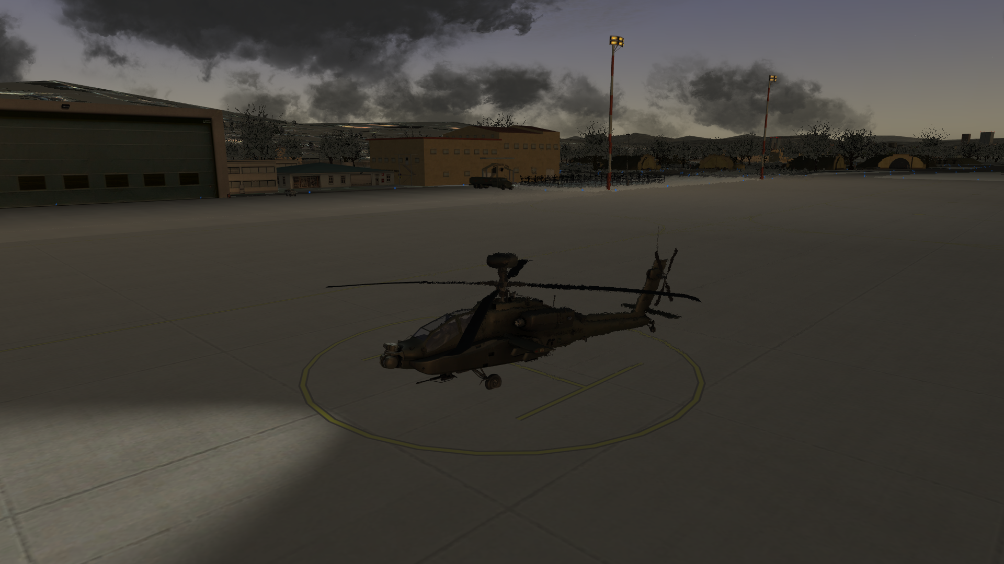Figure 15: We made it home. Was there ever any doubt that you could do it?
Crashed and burned? Next time, pay more attention to your FPM. Perhaps you need to make adjustments earlier than you think.
Landed in one piece? Good.
Landed in one piece within the time allocated? Fantastic. Congratulations. You’re handling yourself like a pro now.

Helipack Training 04 (Naval)
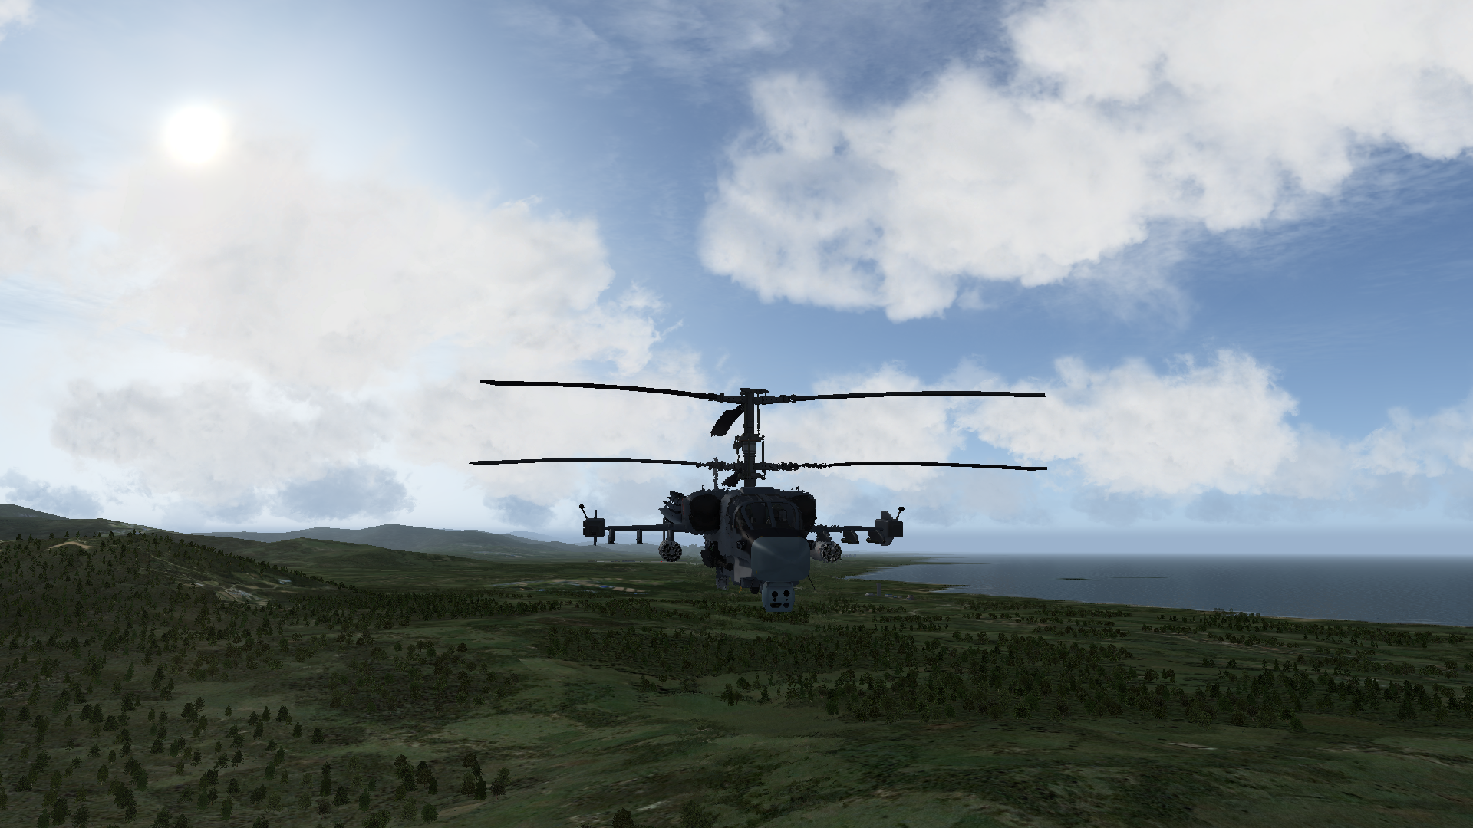Figure 16: A Russian KA-52 with its signature main rotors. This mean helicopter can shred ground troops with ease.
Goal: To be able to take off and land on a carrier in a KA-52K.
Mission Background: The Russian navy is running a carrier ops training mission. American forces in South Korea are trying to ease tensions between NATO and Russian forces by performing joint training exercises. Today they are welcoming you, a KA-52K pilot, to one of the South Korean training ranges. Fly there, shoot up some designated targets, and go home. Don’t cause an international incident.
Prior to Loading into Falcon BMS: It is optional, but you should consider binding the VTOL Increase Angle and VTOL Decrease Angle buttons. The default keyboard commands for these callbacks are Shift + Period and Shift + Comma respectively.
When in 2D: Slot into Gazelle 5. Note the killbox that is drawn on the map. Your target is a cargo ship and two Ulsan CLS. The Koreans don’t need these vessels, and the Americans have convinced them to let you blow them up.
Perform the “click dance,” ensuring you have your comms ladder properly saved into your DTC. You’re ready to commit. Select Ramp or Taxi start.
When in 3D: If you selected Ramp Start, begin by performing your ramp start as you would if you were in the F-16.
Set STPT 2, and taxi forward so as to clear the main part of the Kuznetsov. Set VTOL to 90°. Your Never Exceed Speed is 189kts.
Once you’re ready to take off, do so quickly. The relative motion of the platform won’t stick with you. You’ll be suddenly aware of just how quickly the carrier is moving compared to you. Once you’re clear and have raised your gear, move quickly away from the carrier.
The Americans are conducting their own training on the training range. While your targets are naval vessels, their targets are on a small island east of your AO. Between STPT 2 and STPT 4, the American pilots may decide to buzz you. If so, just pop a flare and wave back. Now is not the time for you to cause an incident.
Power on your weapons and begin searching for the naval vessels. When you find them, engage safely. They might shoot back. After all, this is a hostile area you’re training in.
Egress and Landing: When you’ve blown up all three vessels, it’s time to head back. Now comes the fun part: landing on a moving platform.
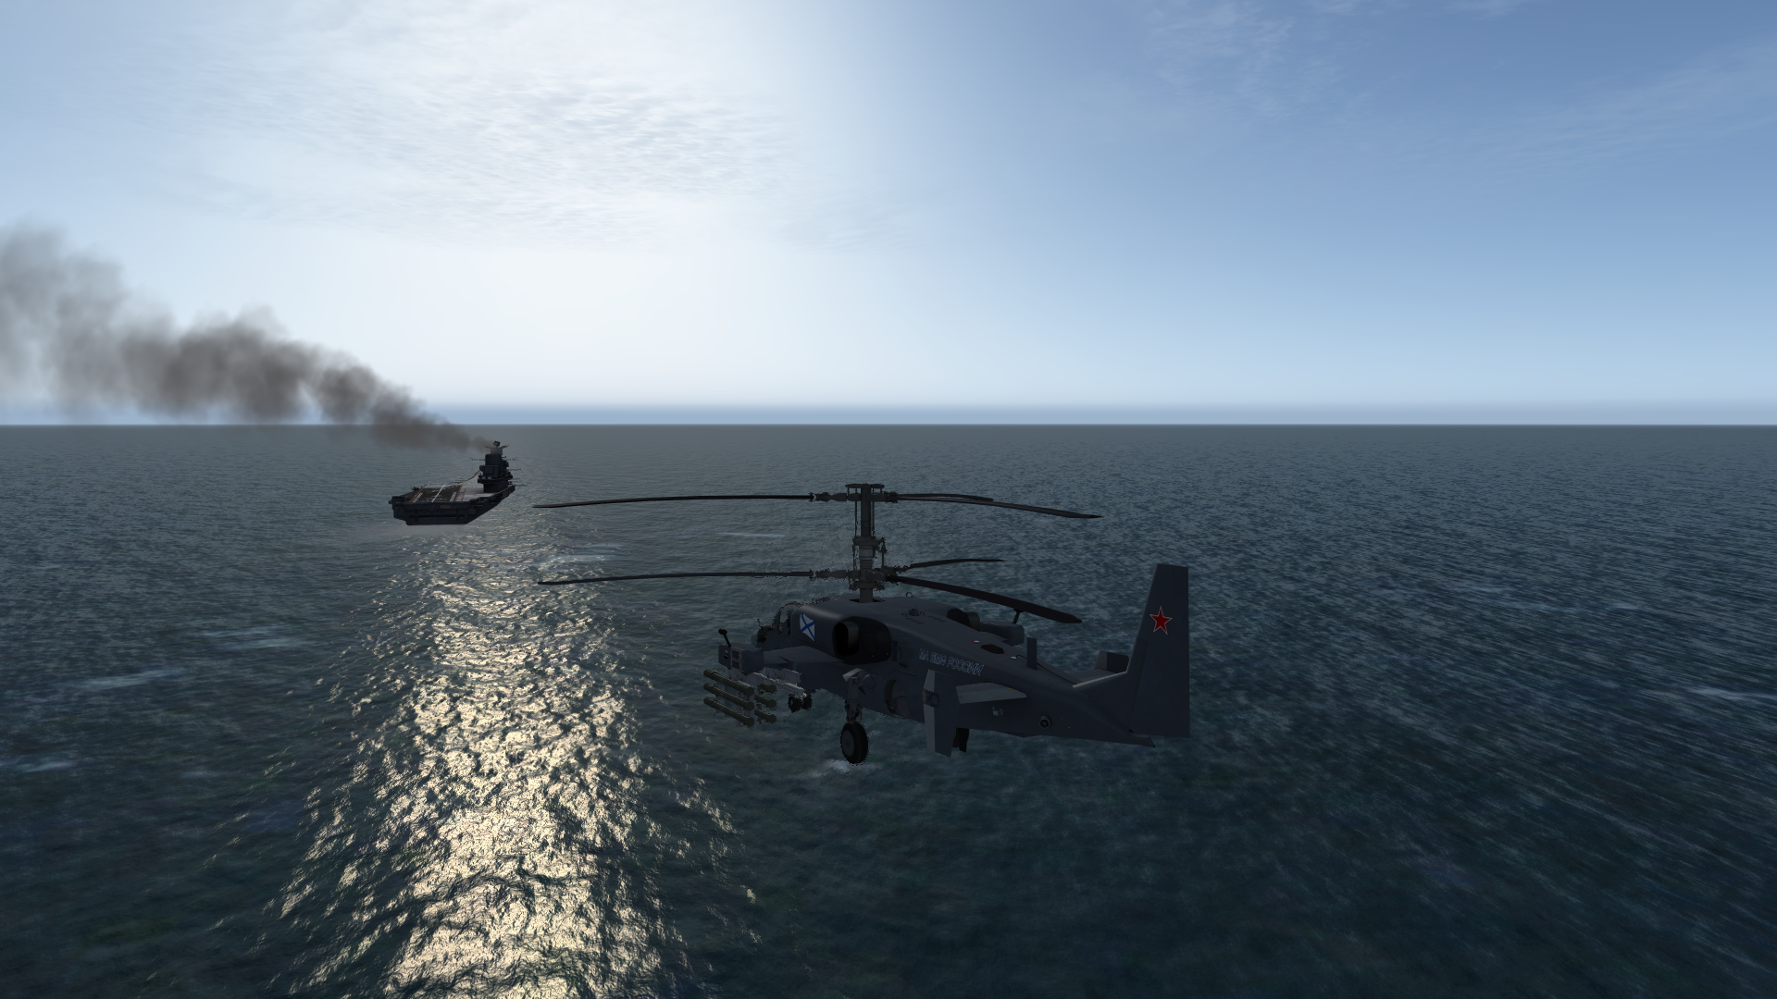Figure 17: A carrier landing can be difficult, but the low speed of the helicopter might prove to make it easier.
The trick is to get behind the Kuznetsov as it’s moving away. You can overtake the carrier by moving ever so slightly faster. When you’re very close, and slowly overtaking, drop your gear and lower your hook. Touch down where the landing cables are.
If you missed the cable, and you can’t stop, put the throttle back on, and take off again. It’s better to try again than force a bad landing.
If you’ve done it right, you should begin sliding toward the end of the carrier only to meet a sudden jolt as the cable catches. Hit the brakes as soon as you touch down, and pay attention if the cable catches, and you feel the jolt.
If you’re able to stop, raise the hook. Park the helicopter, and shut it down.
Congratulations. You’re capable of naval operations.

Helipack Training 05 (Night Ops)
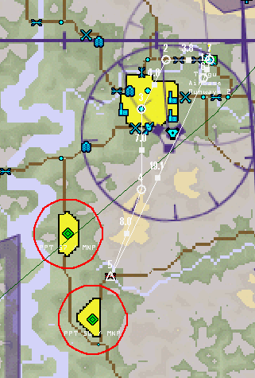Figure 18: The two M16 units will shoot at you if you get too close. Use the terrain for cover, or move to a safer location for your attack.
Goal: To be able to operate the AH-64E during night operations.
Mission Background: Sometimes bridges need to be destroyed in order to stop an advance. This is your current task – but you have to do it during the night.
Prior to Loading into Falcon BMS: It is optional, but you should consider binding the VTOL Increase Angle and VTOL Decrease Angle buttons. The default keyboard commands for these callbacks are Shift + Period and Shift + Comma respectively.
You will be expected to know how the FLIR works. If you do not, then consult the appropriate Falcon BMS manual first before doing this mission.
When in 2D: Slot into Nighthawk 1. Open your DTC and ensure that the following targets are already set:
- STPT 99: Ch’angnyong Bridge – 35^ 39.202’ / 129^ 43.618
If this is not correct, then assign the STPTs manually as follows:
- Recon STPT 5 and assign STPT 99 to the first target from the top: “!Bridge”
There are two hostile M16 infantry units that are allowed to shoot at you. This training mission will have live fire. The two units should be marked by default. If you don’t have PTTs on their locations, see the screenshot associated with this mission and mark them manually.
If you plan on boresighting your AGM-114 missiles, consider selecting a target at STPT 3 and assigning it to STPT 98.
Perform the “click dance,” ensuring you have your comms ladder properly saved into your DTC. You’re ready to commit. Select Ramp or Taxi start.
When in 3D: If you selected Ramp Start, begin by performing your ramp start as you would if you were in the F-16.
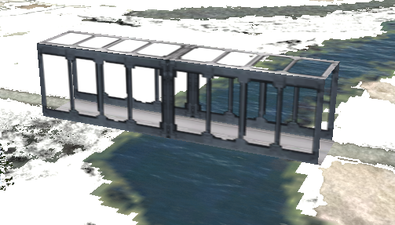Figure 19: The Ch'agnyong Bridge during the day.
Prior to taking off, power on both the AGM-114 missiles and the FLIR. Turn up the brightness on the ICP for the FLIR. It’ll be fairly dark tonight, and night vision won’t do much for you to see the ground at night when you’re away from the city, even at close proximity. The FLIR will make up for this by ensuring you can see directly in front of you.
The danger of night flying is becoming disoriented and crashing the helicopter. You’ll need to rely on your HUD more than in the daytime. The FLIR will help you establish a sense of altitude and direction, in addition to helping you spot changes in elevation ahead, but you’ll need to maintain awareness of your FPM and altitude just the same.
STPT 3 is where you can boresight both the FLIR and AGM-114 missiles if you would like. This is entirely up to you how you would like to proceed. If you would like to boresight the AGM-114 missiles, then turn Master Arm to SIM, and follow the boresighting procedure. When you are finished, turn Master Arm to OFF. Consider powering the AGM-114 missiles off as well.
When leaving STPT 3, you should notice two things:
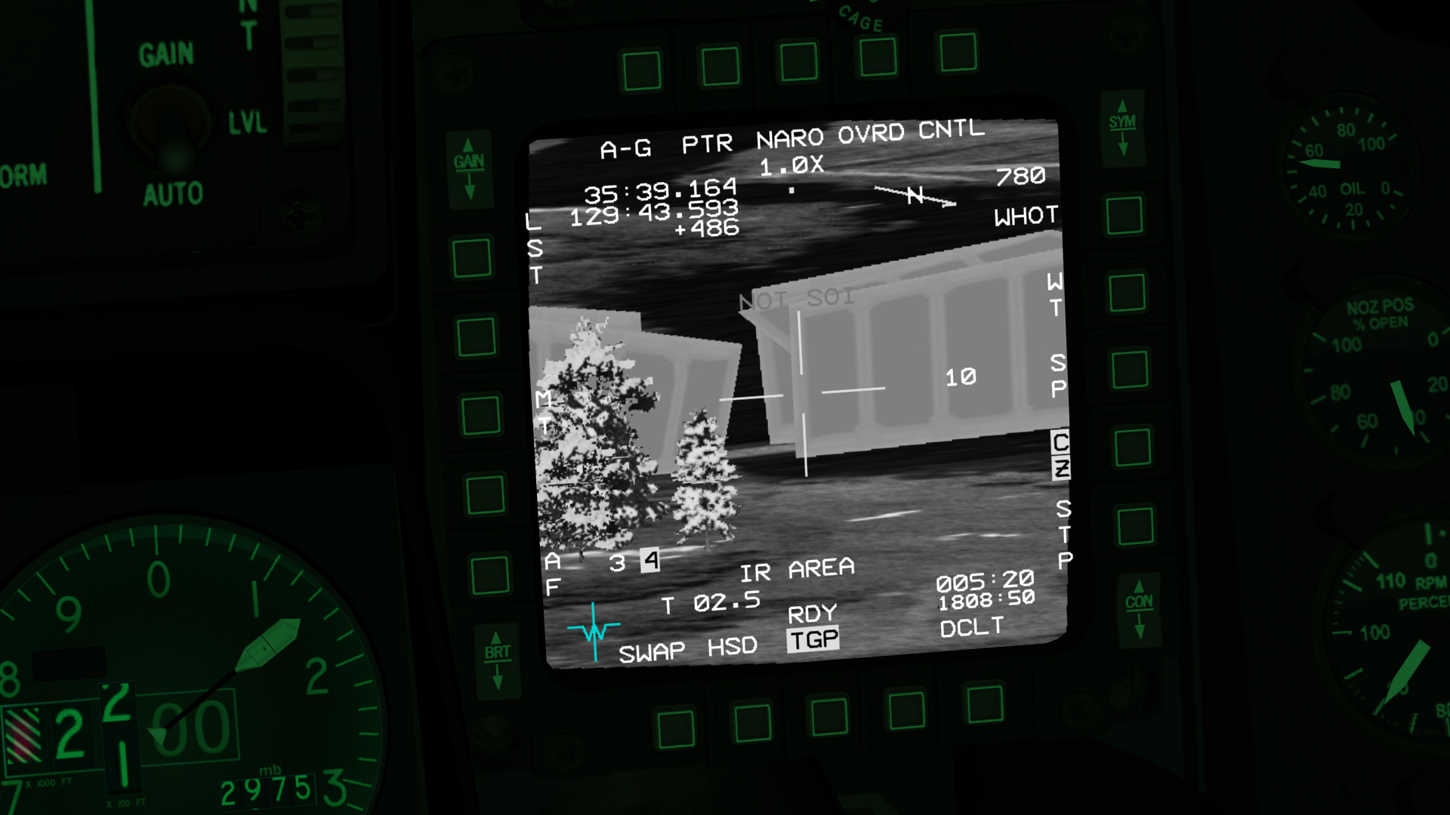Figure 20: This is what a TGP capture of the destroyed bridge looks like. In this run of the mission, it took 4 direct hits from the AGM-114.
- The city lights will shine less in front of your path. Maintaining visual with the ground will become harder with default night settings in Falcon BMS. You will need to rely more on the FLIR.
- The terrain leading to STPT 4 will become rather mountainous. Do not exceed 200ft AGL. Proceed cautiously from here on out.
Your target is at STPT 5. When you have the bridge in sight, decide on your choice of weapons. You can use the AGM-114, the LAU-3/A /HE (G), or the guns. Make sure you are aware of the locations of the enemy infantry battalions.
When you are able, destroy the bridge, and then confirm that it is destroyed. The bridge is reinforced. It will take multiple direct hits before you destroy it. Upon confirming the destruction of the target, fly back home and land.
Congratulations. You’re qualified for night ops.

Tactical Engagements
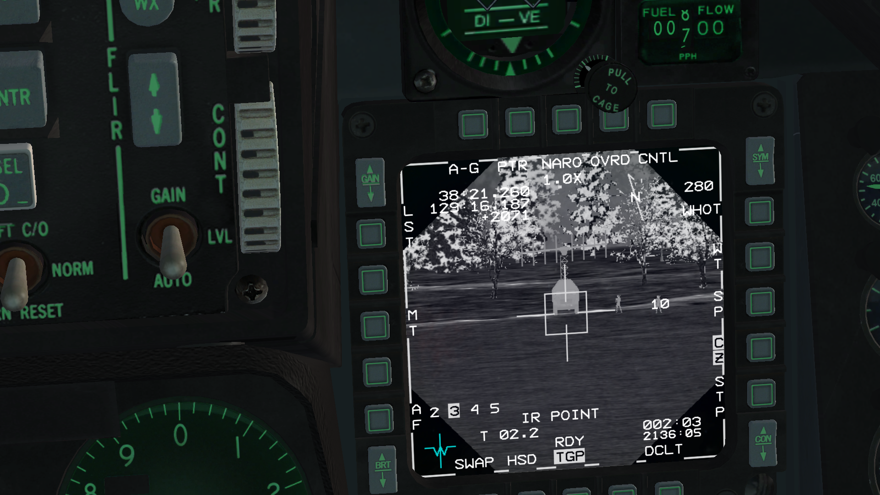Figure 21: A prowling AH-64D uses the TGP to capture a SAM radar and some soldiers with anti-air weapons. The tables have been turned.
Most of these missions have been designed with multiplayer in mind. While they can be flown alone, it’s probably best to arrange for some human help. Also, it’s highly recommended that you fly with a GCI.

Helipack 01 SCUD Hunt
North Korea is moving six SCUD launchers to the border. It’s time to respond to this aggression.
This mission was flown November 24, 2021 at the Falcon Lounge. During that run of the mission, we had human GCI operating on UHF. In addition, the F-16 SEAD flight was eliminated from the tasking since we opted to fly with 10 people instead of the full 14 slots allowed.
It is recommended that you fly this with a minimum of 10 pilots, completely filling the CAP, AI, and helicopter SEAD flights. It is also recommended that you use human GCI.
The PDF that was used for briefing that includes a full description of the mission has been included in the documentation with this theater. Feel free to use that briefing as a template for your own run of the mission.
Minimum Recommend Pilot Count: 10
Mission Tasking:
- 12xF-16CM Block 50
  - 4xCAP
  - 4xAI
  - 4xSEAD
- 2xAH-64D: SEAD
Happy hunting!

Helipack 02 Light Blitz
North Korea is attempting to blitz the east coast and capture Sokcho during a storm. Defend the city.
This mission was scheduled to be flown December 15, 2021 at the Falcon Lounge to celebrate the pre-release of version 0.2. Unfortunately, the event had to be canceled due to low attendance. It was eventually flown on December 21, 2021 with a shorthanded crew.
It is recommended that you fly this with a minimum of 9 pilots, putting 3 pilots in each CAP, 1 in the STRIKE, and 2 in the helicopter CAS. It is also recommended that you use human GCI.
The PDF that was created for the live briefing has been included in the documentation with this theater. It has a full description of the mission. Feel free to use that briefing as a template for your own run of the mission.
Minimum Recommend Pilot Count: 9
Mission Tasking:
- 2xAH-64D: CAS
- 10xF-16CM Block 50
  - 4xCAP
  - 4xCAP
  - 2xSTRIKE

Helipack 03 Defensive Nightmare
South Korea must defend against a massive, surprise invasion. Can a package of AH-64s hold off the advance?
This mission should be supplied in an update.

Helipack 04 Escape From North Korea
Your AH-64 escorted a flight carrying a commando team into North Korea. Unfortunately, an emergency forced you to land and repair. The helicopter was fixed, but you’re an hour later than planned. Your window to escape is all but closed. Destroying the helicopter is not an option, and you can’t let it fall into enemy hands. Can you make it back to South Korea?
This mission should be supplied in an update.

Helipack 05 Alligator Attack
Привет, товарищ. You’re a Russian pilot operating off of the Kuznetsov. NATO expansion has increased tensions between the West and East. This is your chance to fight back. Your target is a NATO cargo ship carrying new American missile technology. Previous plans to steal the missiles have failed, but you can destroy the cargo ship here. Russian divers will attempt a salvage operation, after your attack, to recover whatever they can.
This mission should be supplied in an update.

Helipack PvP 01 Mirror Skirmish
Two Red T-90 battalions are engaging one lone Blue Abrams battalion. 2xAH-64E are dispatched by BLUFOR while 2xKA-52 are dispatched by REDFOR. Each side sends in fighters.
This mission should be supplied in an update.

Campaigns
Unfortunately, campaigns can be a bit complex. As such, we’ve released this version of the theater without any campaigns.
If you’re well-versed with Mission Commander, you may edit a campaign save file with a new squadron of helicopters.
It is hoped that we will provide well-designed campaigns in the future.

Strategy, Tactics, and Limitations

Role
The helicopters that are flyable are well-suited for taking out ground targets quickly. With 16 AGM missiles on the AH-64, this can be a strong asset to deal with the ground war. When traveling with multiple humans, the force multiplier becomes significant as it will be possible to wipe out battalions quickly and efficiently. Sometimes battalions replenish lost vehicles at an alarming rate, requiring you to wipe them out in one attack. This is certainly possible with a full flight of helicopters.
Another possible role for the helicopters is to provide FAC services, guiding other aircraft to drop their bombs on designated targets. This will require some significant coordination.

Systems

FCR
For the helicopters that have it, the FCR is going to help you maintain Situational Awareness when traveling in enemy territory. Be very careful when traveling around cities and bridges. Manpads, AAA, and SAMs all await for you. The FCR is your way of obtaining advanced information.
If you lack an FCR, you must be vigilant. Look around you. Noticing the smoke from a launched SAM might save you.

TGP
The TGP is how you’re going to spot units on the ground. The IR mode is particularly effective at picking out units on the ground, whether vehicles or soldiers on the battlefield. You’ll need to be careful to scan wide swaths of land. Just when you think you’ve wiped out a battalion, a manpad might be hiding among the trees ready to fire at you.
Don’t forget to use the FCR first. The FCR may point you to where an enemy battalion is; the TGP helps you find and prosecute the actual units.

Data Link
Pilots should take care to plan their mission effectively. For static targets, it is possible that multiple helicopters can have their targets already assigned, allowing each pilot to arrive at the target and begin processing targets immediately.
For moving ground targets, the pilots must coordinate with each other not to shoot at the same targets. Using the data link and having an SOP for target sorting would most likely be the prudent course of action.

Laser
Pilots should use the lasers on their TGPs for pointing out moving targets. In future versions, some weapons on the helicopters may be laser guided.
Buddy lasing for aircraft, such as for F-16s dropping LGBs, might also be a viable tactic.

Radio
Due to the need for terrain masking, it is likely that you will lose radio contact with your human wingman/teammate as one of you ducks behind a hill. The general rule is that if a visual line-of-sight is maintained, your radio is working.
Beyond that, you will have difficulty in maintaining radio contact with a package. It is best to fly package missions with a human GCI who is able and willing to relay messages between the helicopters and the rest of the package.

Buddy System
If you’re flying with a wingman, it might be wise to space the flight out. Depending on the terrain and situation, it may be advisable to have one helicopter fly in front, and another in trail. If the trailing helicopter notices a SAM launch on the leading helicopter, he can call it on the radio while using VIS mode to obtain a lock on the SAM in question.

Weapons
Figure 22: An earlier version of Helipack. This helicopter fired all of its rockets in one salvo. Currently this is fixed so 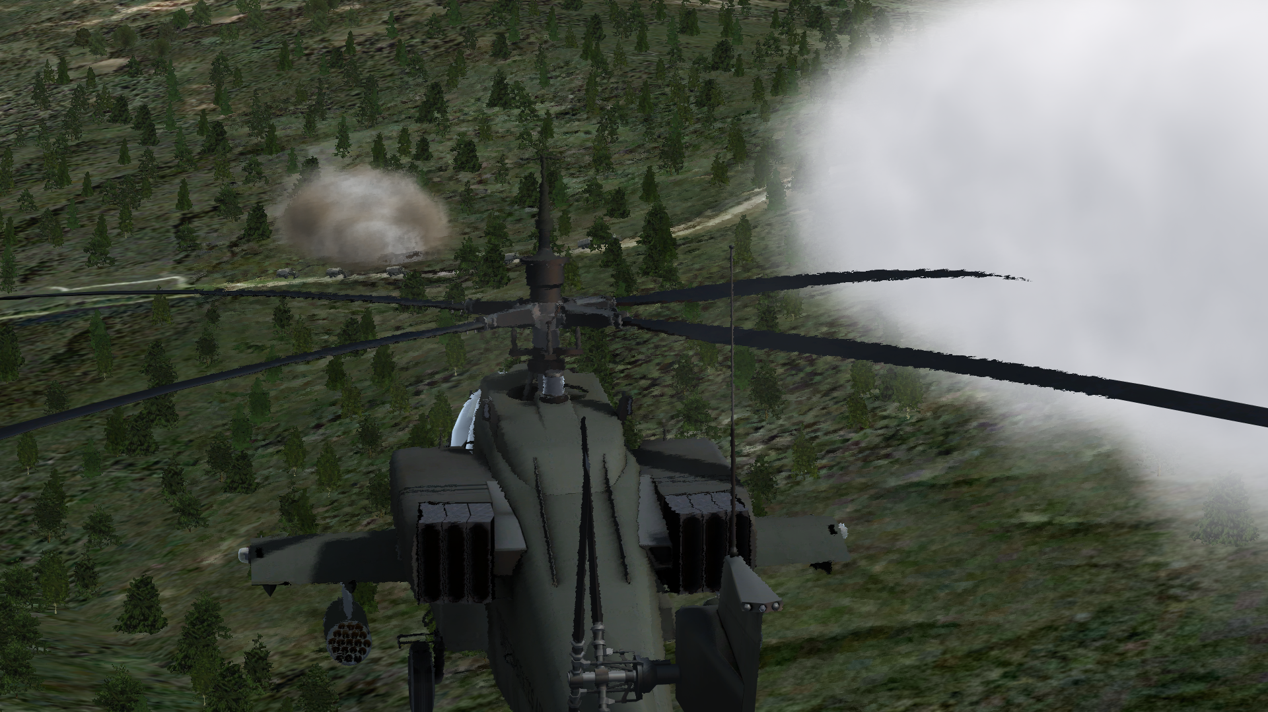that the pilot can fire them in single or pair.
The weapons are divided into the following categories:
- Guns
- Rockets
- AG Missiles
- AA Missiles
The bread and butter of any ground attack at present will be the Missiles. This is due to current engine and theater limitations.

Guns
- 30mm M230
- 20mm M39-2
- GSh-23-6
The guns behave just like the F-16 cannon. The gun cannot be slewed like it can in some real helicopters, which is an unfortunate travesty. The gun can be selected and deselected by a long press of Cursor Enable when in AG Master Mode. Of note, you can use your TGP to see where the gun sights are pointed.
In order to slew the gun, official developer support will most likely be needed.

Rockets
- LAU-3/A /HE (G)
- LAU-3/A MPSM (G)
- LAU-68/131 /HE
- LAU-68/131 /WP
- LAU-68/131 /MPSM
- B8V20-A
Rockets have been improved in this theater. The rocket pod will not release all of its rockets when a launch is requested by the pilot, but will fire in either single or else pair depending on what the pilot has selected.
Unfortunately, all rockets are fire-and-forget with absolutely no guidance. This makes them less than ideal for taking out moving targets. They can be used for taking out large static objects, like buildings.

AG Missiles
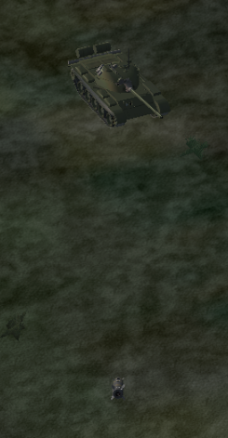Figure 23: An AGM-114 is about to strike a tank.
- Maverick-based implementations:
  - AGM-114 Hellfire
  - BGM-71 TOW
  - AT-9
  - AS-10MR (Kh-25)
- Harpoon-based implementations:
  - AS-20 (Kh-35)
Maverick-based Implementations: All of the above missiles are considered internally by Falcon BMS to be Mavericks, except for the AS-20 (Kh-35), which is considered to be a Harpoon variant. Essentially, for the Maverick-based missiles, each helicopter is carrying AGM-65s that have some strange quirks.
- Boresighting works and is recommended, however, each missile will never auto-lock when given a target via handoff. Each missile must be manually assigned a target via the WPN page.
- When the missile hardpoints are cycled, the previously selected missile will lose its lock. Always confirm that you have the option to boresight the selected missile before you fire. This means you have a lock.
Harpoon-based Implementations: The AS-20 (Kh-35) seems to be based internally off of the Harpoon. It complains that the KA-52K is too slow and too low. If you can get these missiles to work, they should help in TASMO missions.

AA Missiles
- AIM-92 Stinger
- AA-11 (R-73)
- AA-8 (R-60)
These missiles behave like the AIM-9. They are heat seeking missiles. It is useful to remember that it is possible to decouple the heat seeker from the FCR in Dogfight Override by holding Cursor Enable.

References
- Github: https://github.com/BibleClinger/HeliPack
- Trello: https://trello.com/b/C5C9tWjD/helipack
- Falcon Lounge Discord: https://discord.com/invite/KQNHQBz

This change has been incorporated into a future Falcon BMS version.
This change may be incorporated into a future Falcon BMS version.
This change has been incorporated into a future Falcon BMS version.
Thanks to [BVT_22]Eagle_Eye for the idea.
The Falcon Lounge is a regular hangout for Falcon BMS pilots. It’s not dedicated to this project.

